STANDARD SCALING
import numpy as np

class StandardScaler:
"""
A class for standardizing features by removing the mean and scaling to unit variance.

The standard score of a sample x is calculated as:
z = (x - mean) / std

Attributes:
mean_ (numpy.ndarray): Mean values for each feature in the training set.
scale_ (numpy.ndarray): Standard deviations for each feature in the training set.
var_ (numpy.ndarray): Variance for each feature in the training set.
"""

def __init__(self):
self.mean_ = None
self.var_ = None
self.scale_ = None

def fit(self, X):
"""
Compute the mean and standard deviation to be used for later scaling.

Parameters:
X (numpy.ndarray): Training data, shape (n_samples, n_features)

Returns:
self (StandardScaler): The fitted scaler
"""
# Ensure X is a numpy array
X = np.array(X, dtype=np.float64)

# Calculate mean and variance along axis 0 (features)
self.mean_ = np.mean(X, axis=0)
self.var_ = np.var(X, axis=0)

# Add small epsilon to avoid division by zero
self.scale_ = np.sqrt(self.var_ + 1e-8)

return self

def transform(self, X):
"""
Perform standardization by centering and scaling data.

Parameters:
X (numpy.ndarray): Data to transform, shape (n_samples, n_features)

Returns:
numpy.ndarray: Transformed data
"""
# Ensure X is a numpy array
X = np.array(X, dtype=np.float64)

# Check if fit has been called
if self.mean_ is None or self.scale_ is None:
raise ValueError("StandardScaler instance is not fitted yet. "
"Call 'fit' before using this method.")

# Perform standardization
X_scaled = (X - self.mean_) / self.scale_

return X_scaled

def fit_transform(self, X):
"""
Fit to data, then transform it.

Parameters:
X (numpy.ndarray): Training data, shape (n_samples, n_features)

Returns:
numpy.ndarray: Transformed data
"""
# Fit the data
self.fit(X)

# Transform the data
return self.transform(X)

# Example usage:
if __name__ == "__main__":
# Create some sample data
np.random.seed(42)
X_train = np.random.randn(100, 3) * [10, 5, 2] + [5, -3, 1]
X_test = np.random.randn(20, 3) * [10, 5, 2] + [5, -3, 1]

# Create and fit the scaler on training data
scaler = StandardScaler()
scaler.fit(X_train)

# Transform both training and test data
X_train_scaled = scaler.transform(X_train)
X_test_scaled = scaler.transform(X_test)

# Print statistics
print("Original training data statistics:")
print(f"Mean: {np.mean(X_train, axis=0)}")
print(f"Std dev: {np.std(X_train, axis=0)}")

print("\nScaled training data statistics:")
print(f"Mean: {np.mean(X_train_scaled, axis=0)}")
print(f"Std dev: {np.std(X_train_scaled, axis=0)}")

print("\nScaled test data statistics:")
print(f"Mean: {np.mean(X_test_scaled, axis=0)}")
print(f"Std dev: {np.std(X_test_scaled, axis=0)}")

COLUMN TRANSFORMER WITH THE PIPELINE

import pandas as pd
from sklearn.compose import ColumnTransformer
from sklearn.preprocessing import StandardScaler, OneHotEncoder
from sklearn.pipeline import Pipeline
from sklearn.linear_model import LogisticRegression
from sklearn.model_selection import GridSearchCV

# Sample DataFrame
df = pd.DataFrame({
'age': [25, 32, 47, 51],
'salary': [50000, 60000, 80000, 90000],
'gender': ['Male', 'Female', 'Female', 'Male'],
'city': ['New York', 'Paris', 'Berlin', 'New York']
})

X = df[['age', 'salary', 'gender', 'city']]
y = [0, 1, 0, 1]

# Define columns by type
num_features = ['age', 'salary']
cat_features = ['gender', 'city']

# Define preprocessing steps
preprocessor = ColumnTransformer(
transformers=[
('num', StandardScaler(), num_features),
('cat', OneHotEncoder(), cat_features)
]
)

# Build pipeline with a model
pipeline = Pipeline(steps=[
('preprocess', preprocessor),
('classifier', LogisticRegression(solver='liblinear')) # liblinear is good for small datasets
])

# Define hyperparameter grid for logistic regression
param_grid = {
'classifier__C': [0.01, 0.1, 1.0, 10.0], # Inverse of regularization strength
'classifier__penalty': ['l1', 'l2']
}

# Setup GridSearchCV
grid_search = GridSearchCV(
estimator=pipeline,
param_grid=param_grid,
cv=3, # 3-fold cross-validation
scoring='accuracy', # or use 'f1', 'roc_auc', etc.
verbose=1
)

# Run grid search
grid_search.fit(X, y)

# Results
print("Best Parameters:", grid_search.best_params_)
print("Best Cross-Validation Score:", grid_search.best_score_)

Sure! Let's go step-by-step and explain what each line is doing in your program. I'll break it down by functionality, explaining the purpose, used functions, and their core workings in a very clear format.

✅ Libraries Used
import numpy as np
import pandas as pd
import matplotlib.pyplot as plt
import seaborn as sns

- numpy (np): Used for numerical operations, like np.where() to conditionally replace values.
- pandas (pd): Handles tabular data using DataFrames (like df).
- matplotlib.pyplot (plt) and seaborn (sns): Used for plotting (though not used in your provided code, but may be for visualization later).

📌 Skewness of Placement Marks
df['placement_exam_marks'].skew()

- skew() measures the asymmetry of the distribution:
- > 0 → right-skewed
- < 0 → left-skewed
- = 0 → symmetric

📌 Summary Statistics of CGPA Column
print("Mean value of cgpa", df['cgpa'].mean())

- Calculates the average value of the 'cgpa' column.
print("Std value of cgpa", df['cgpa'].std())

- Calculates the standard deviation, which tells how spread out the CGPA values are.
print("Min value of cgpa", df['cgpa'].min())
print("Max value of cgpa", df['cgpa'].max())

- Fetches the minimum and maximum CGPA values.

📌 Finding 3σ (Z-score) Thresholds (Outlier Boundaries)
print("Highest allowed", df['cgpa'].mean() + 3 * df['cgpa'].std())
print("Lowest allowed", df['cgpa'].mean() - 3 * df['cgpa'].std())

- This is the core logic to define the outlier range using the Empirical Rule (Z-score method).
- 🔹 Formula:
- upper_limit = mean + 3 * std
- lower_limit = mean - 3 * std

- Any value outside this range is considered a potential outlier.

📌 Identify Outliers in CGPA
df[(df['cgpa'] > 8.80) | (df['cgpa'] < 5.11)]

- Filters rows where CGPA is greater than 8.80 or less than 5.11
- These limits appear to be previously calculated as mean ± 3σ

📌 Trimming the Outliers
new_df = df[(df['cgpa'] < 8.80) & (df['cgpa'] > 5.11)]

- Creates a new DataFrame (new_df) excluding outliers
- Keeps only values within the allowed CGPA range

📌 Calculate Z-score for Each Row
df['cgpa_zscore'] = (df['cgpa'] - df['cgpa'].mean()) / df['cgpa'].std()

- Adds a new column 'cgpa_zscore' containing the Z-score of each CGPA value
- Z-score formula:
- Z = (X - μ) / σ

📌 Filter Outliers Using Z-score
df[df['cgpa_zscore'] < -3]
df[(df['cgpa_zscore'] > 3) | (df['cgpa_zscore'] < -3)]

- First line: filters rows with very low CGPA (Z < -3)
- Second line: filters both high and low outliers

📌 Keep Only Non-Outliers Based on Z-score
new_df = df[(df['cgpa_zscore'] < 3) & (df['cgpa_zscore'] > -3)]

- Creates a clean DataFrame with non-outlier CGPA values only

📌 Capping Outliers (Winsorization using np.where())
upper_limit = df['cgpa'].mean() + 3 * df['cgpa'].std()
lower_limit = df['cgpa'].mean() - 3 * df['cgpa'].std()

df['cgpa'] = np.where(
df['cgpa'] > upper_limit,
upper_limit,
np.where(
df['cgpa'] < lower_limit,
lower_limit,
df['cgpa']
)
)

🔹 What This Does:
- This caps all extreme values (outliers) to the boundary values:
- Values above upper limit → replaced with upper_limit
- Values below lower limit → replaced with lower_limit
- All other values stay the same

🔹 Function Breakdown:
- np.where(condition, value_if_true, value_if_false)
- It's a vectorized if-else, applied to the entire column efficiently.

📌 Descriptive Statistics After Capping
df['cgpa'].describe()

- Gives summary stats like count, mean, std, min, max, 25%, 50%, 75% percentiles after outlier handling.

✅ Summary of Core Functional Code Snippets
Code | Purpose
df['cgpa'].mean() | Compute average CGPA
df['cgpa'].std() | Compute spread of CGPA
df['cgpa'] > upper_limit | Identifies values above normal
np.where(df['cgpa'] > upper_limit, upper_limit, ...) | Caps values to upper bound
df['cgpa_zscore'] = (df['cgpa'] - mean)/std | Z-score for each row
`df[(df['cgpa_zscore'] > 3) | (df['cgpa_zscore'] < -3)]`
df['cgpa'].describe() | View updated stats after processing
Would you like me to plot a before/after histogram or boxplot to visualize how outliers were trimmed or capped?

df['placement_exam_marks'].describe() – statistical overview
sns.boxplot(df['placement_exam_marks'])
sns.distplot(df['placement_exam_marks'])
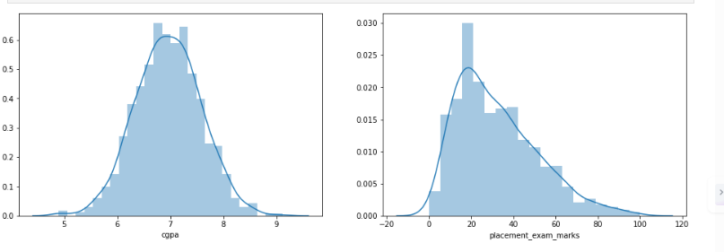
percentile25 = df['placement_exam_marks'].quantile(0.25)- can do it for others too
iqr = percentile75 - percentile25
upper_limit = percentile75 + 1.5 * iqr
lower_limit = percentile25 - 1.5 * iqr
df[df['placement_exam_marks'] > upper_limit]
df[df['placement_exam_marks'] < lower_limit]
new_df = df[df['placement_exam_marks'] < upper_limit]

new_df_cap = df.copy()
new_df_cap['placement_exam_marks'] = np.where( new_df_cap['placement_exam_marks'] > upper_limit, upper_limit, np.where( new_df_cap['placement_exam_marks'] < lower_limit, lower_limit, new_df_cap['placement_exam_marks'] ))

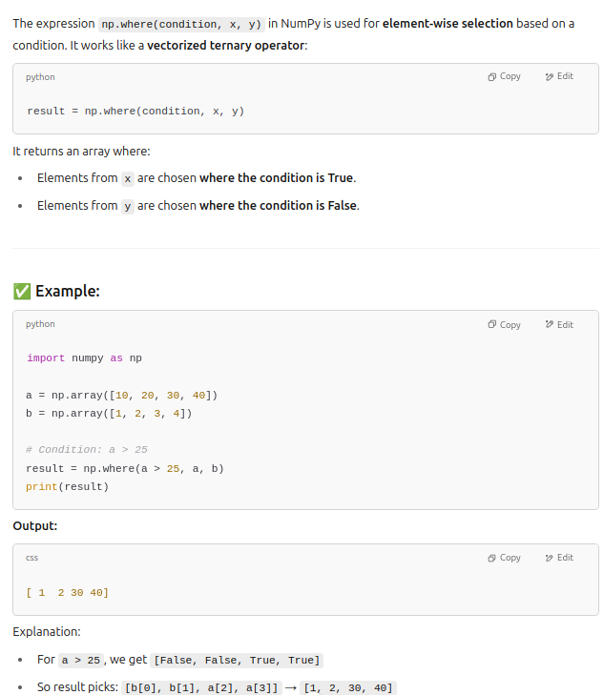

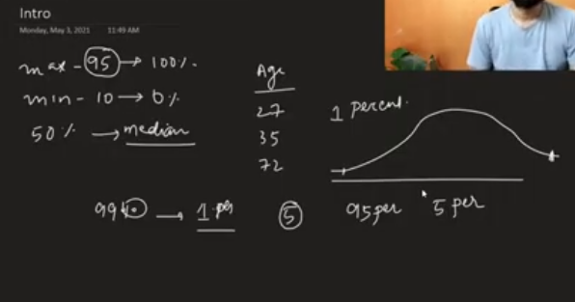

PCA
import numpy as np
import pandas as pd
from sklearn.datasets import fetch_openml

def pca_numpy(df: pd.DataFrame, n_components: int):
"""
Perform PCA using numpy on a pandas DataFrame.

Parameters:
-----------
df : pd.DataFrame
Input data with shape (n_samples, n_features)
n_components : int
Number of principal components to compute

Returns:
--------
eig_vals : np.ndarray
Array of top n_components eigenvalues (shape: (n_components,))
eig_vecs : np.ndarray
Matrix of top n_components eigenvectors (shape: (n_features, n_components))
components_ : np.ndarray
Principal components matrix (shape: (n_components, n_features))
"""
# Convert to numpy array
X = df.values.astype(float)
# Center the data (zero mean per feature)
X_centered = X - np.mean(X, axis=0)
# Compute covariance matrix (features as variables)
cov_matrix = np.cov(X_centered, rowvar=False)
# Compute eigenvalues and eigenvectors
eig_vals_all, eig_vecs_all = np.linalg.eigh(cov_matrix)
# Sort eigenvalues in descending order
sorted_indices = np.argsort(eig_vals_all)[::-1]
eig_vals = eig_vals_all[sorted_indices][:n_components]
eig_vecs = eig_vecs_all[:, sorted_indices][:, :n_components]
# components_ is just the transpose of eigenvectors
components_ = eig_vecs.T
return eig_vals, eig_vecs, components_

# Example with MNIST dataset
print("Loading MNIST dataset...")
mnist = fetch_openml('mnist_784', version=1, as_frame=False)
X_mnist = mnist['data'] # shape (70000, 784)
df_mnist = pd.DataFrame(X_mnist)

print(f"MNIST DataFrame shape: {df_mnist.shape}")

# Compute PCA for 10 components
n_components = 10
eig_vals, eig_vecs, components_ = pca_numpy(df_mnist, n_components)

print(f"Top {n_components} Eigenvalues:\n{eig_vals}")
print(f"Eigenvectors matrix shape (features × components): {eig_vecs.shape}")
print(f"Components matrix shape (components × features): {components_.shape}")

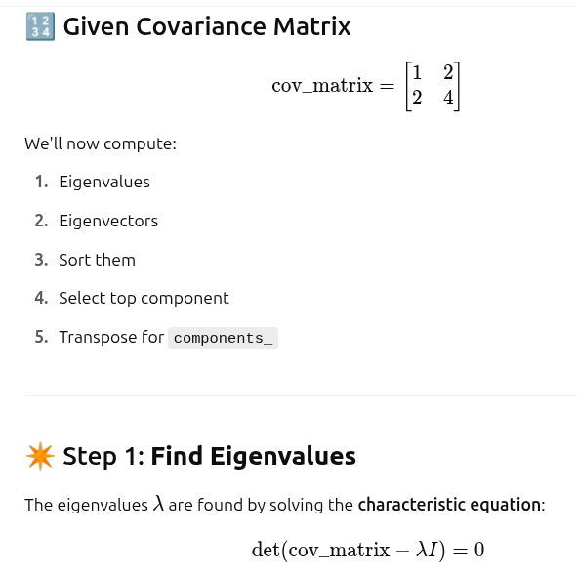

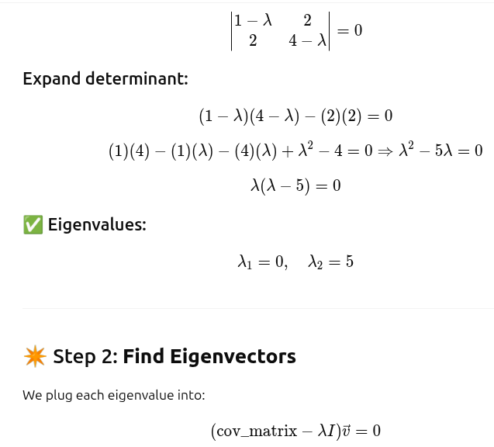

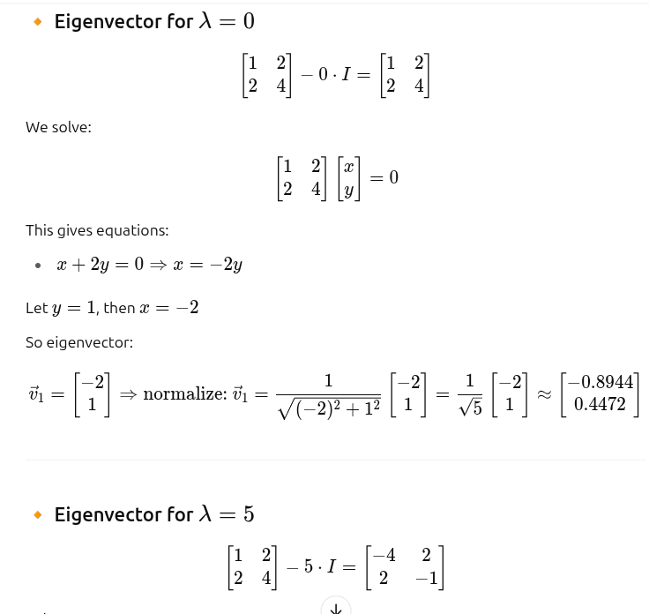
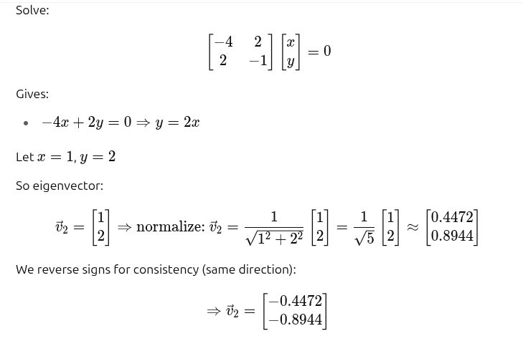

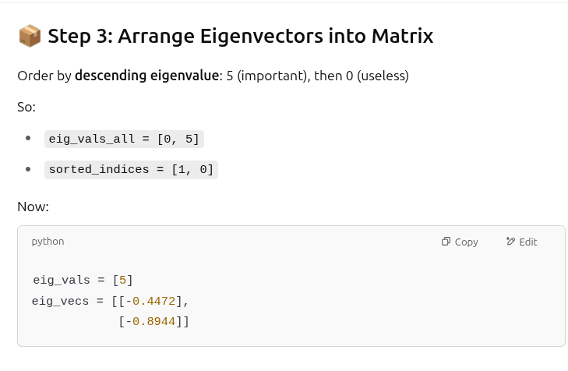
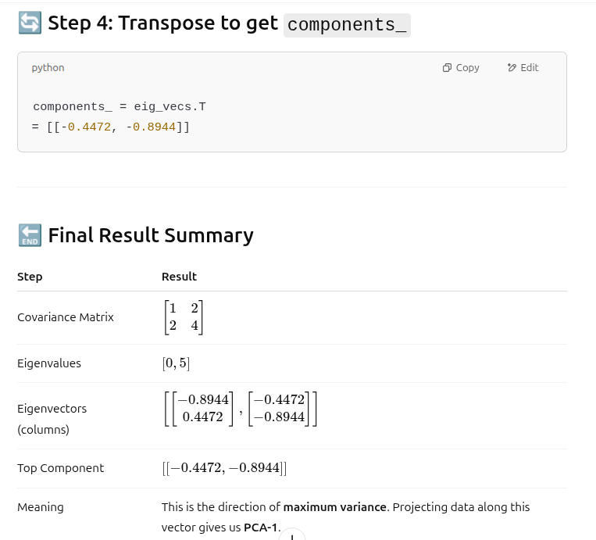
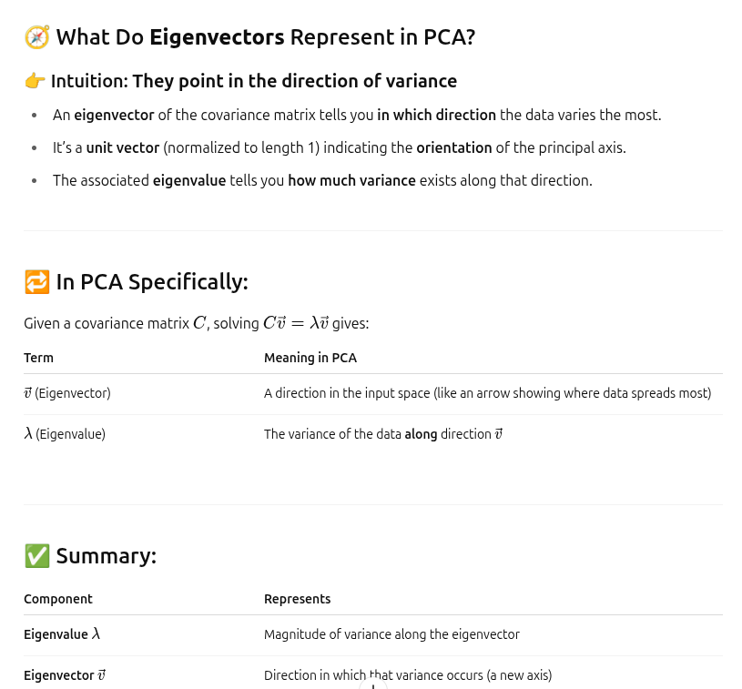

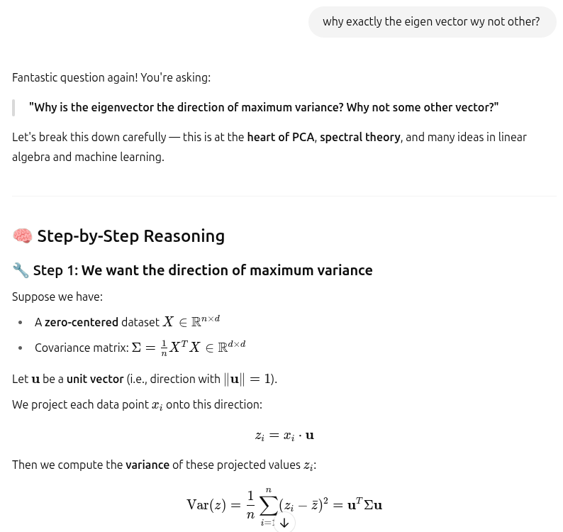

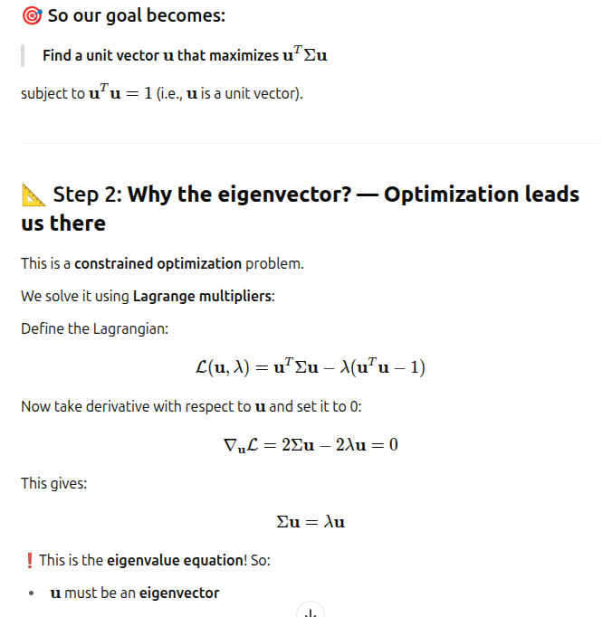

SIMPLE LINEAR REGRESSION

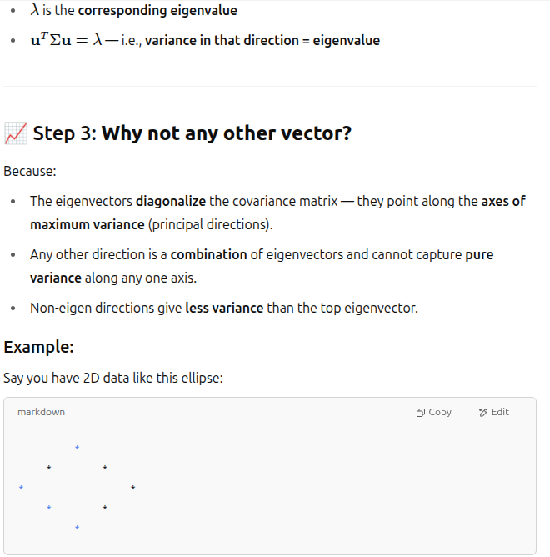

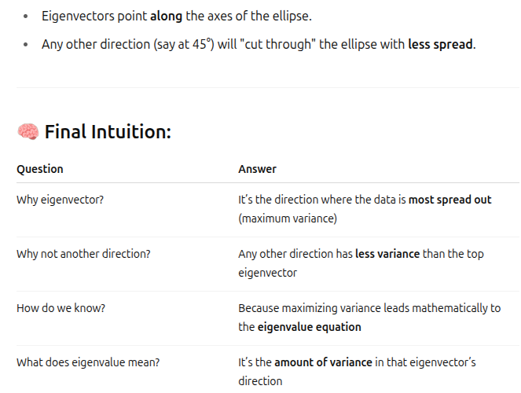

SIMPLE LINEAR REGRESSION

class SimpleLR:

def __init__(self):
self.m = None
self.b = None

def fit(self,X_train,y_train):

num = 0
den = 0

for i in range(X_train.shape[0]):

num = num + ((X_train[i] - X_train.mean())*(y_train[i] - y_train.mean()))
den = den + ((X_train[i] - X_train.mean())*(X_train[i] - X_train.mean()))

self.m = num/den
self.b = y_train.mean() - (self.m * X_train.mean())
print(self.m)
print(self.b)

def predict(self,X_test):

print(X_test)

return self.m * X_test + self.b

Multiple linear regression(OLS):

import numpy as np

class MeraLR:

def __init__(self):
self.coef_ = None
self.intercept_ = None

def fit(self, X_train, y_train):
# Add bias term (column of 1s) to X_train
X_train = np.insert(X_train, 0, 1, axis=1)

# Calculate betas using Normal Equation: (XᵀX)⁻¹ Xᵀy
betas = np.linalg.inv(X_train.T @ X_train) @ X_train.T @ y_train

# First beta is intercept, rest are coefficients
self.intercept_ = betas[0]
self.coef_ = betas[1:]

def predict(self, X_test):
# Make predictions: y = Xw + b
y_pred = X_test @ self.coef_ + self.intercept_
return y_pred

# Example usage with dummy data:
if __name__ == "__main__":
# Create simple training data
X = np.array([[1], [2], [3], [4], [5]])
y = np.array([3, 5, 7, 9, 11]) # y = 2x + 1

# Split (manually, just for illustration)
X_train = X[:4]
y_train = y[:4]
X_test = X[4:]

# Train and test the model
model = MeraLR()
model.fit(X_train, y_train)

print("Learned coefficients:", model.coef_)
print("Learned intercept:", model.intercept_)

y_pred = model.predict(X_test)
print("Predictions on test set:", y_pred)

GD REGRESSOR(SIMPLE LINAR REGRESSION)

import numpy as np
class GDRegressor:

def __init__(self, learning_rate=0.01, epochs=1000):
self.m = 100 # initial slope
self.b = -120 # initial intercept
self.lr = learning_rate
self.epochs = epochs

def fit(self, X, y):
X = X.ravel() # Flatten to 1D array if needed
n = len(X)

for i in range(self.epochs):
y_pred = self.m * X + self.b
error = y - y_pred

# Compute gradients
loss_slope_b = -2 * np.sum(error)
loss_slope_m = -2 * np.sum(error * X)

# Update parameters
self.b -= self.lr * loss_slope_b
self.m -= self.lr * loss_slope_m

# Optional: Print progress every 100 iterations
if i % 100 == 0 or i == self.epochs - 1:
loss = np.mean(error ** 2)
print(f"Epoch {i+1}/{self.epochs}, Loss: {loss:.4f}, m: {self.m:.4f}, b: {self.b:.4f}")

print("\nTraining complete.")
print(f"Final Parameters → Slope (m): {self.m:.4f}, Intercept (b): {self.b:.4f}")

def predict(self, X):
return self.m * X + self.b

Batch GD REGRESSOR(MULTI LINAR REGRESSION)

import numpy as np

class GDRegressor:
def __init__(self, learning_rate=0.01, epochs=1000):
# Will hold weight vector and bias
self.coef_ = None # shape = (n_features,)
self.intercept_ = None # scalar
self.lr = learning_rate
self.epochs = epochs

def fit(self, X_train: np.ndarray, y_train: np.ndarray):
"""
X_train: shape (n_samples, n_features)
y_train: shape (n_samples,)
"""
n_samples, n_features = X_train.shape

# Initialize parameters
self.coef_ = np.zeros(n_features)
self.intercept_ = 0.0

for epoch in range(1, self.epochs + 1):
# 1) Compute predictions
y_pred = X_train @ self.coef_ + self.intercept_

# 2) Compute errors
error = y_train - y_pred # shape (n_samples,)

# 3) Compute gradients
# dJ/db = -(2/n) * sum(error)
intercept_grad = -2 * np.mean(error)
# dJ/dw = -(2/n) * X^T @ error
coef_grad = -2 * (X_train.T @ error) / n_samples

# 4) Update parameters
self.intercept_ -= self.lr * intercept_grad
self.coef_ -= self.lr * coef_grad

# (Optional) Print loss every 100 epochs
if epoch % 100 == 0 or epoch == 1:
loss = np.mean(error**2)
print(f"Epoch {epoch:4d}/{self.epochs} Loss: {loss:.4f}")

print("\nTraining complete.")
print(f"Intercept (b): {self.intercept_:.4f}")
print(f"Weights (w): {self.coef_}")

def predict(self, X_test: np.ndarray) -> np.ndarray:
"""
X_test: shape (m_samples, n_features)
Returns: y_pred shape (m_samples,)
"""
return X_test @ self.coef_ + self.intercept_

STOCHASTIC GRADIENT DESCENT

import numpy as np

class SGDRegressor:

def __init__(self, learning_rate=0.01, epochs=100):
self.coef_ = None
self.intercept_ = None
self.lr = learning_rate
self.epochs = epochs

def fit(self, X_train, y_train):
n_samples, n_features = X_train.shape

# Initialize weights
self.coef_ = np.ones(n_features)
self.intercept_ = 0

for epoch in range(self.epochs):
for _ in range(n_samples):
idx = np.random.randint(0, n_samples)
x_i = X_train[idx]
y_i = y_train[idx]

y_pred = np.dot(x_i, self.coef_) + self.intercept_
error = y_i - y_pred

# Gradients
intercept_grad = -2 * error
coef_grad = -2 * error * x_i

# Update parameters
self.intercept_ -= self.lr * intercept_grad
self.coef_ -= self.lr * coef_grad

print("Training complete.")
print(f"Intercept: {self.intercept_:.4f}")
print(f"Coefficients: {self.coef_}")

def predict(self, X_test):
return np.dot(X_test, self.coef_) + self.intercept_

MINI BATCH GRADIENT DESCENT

import numpy as np

class MBGDRegressor:
def __init__(self, batch_size=32, learning_rate=0.01, epochs=100):
self.batch_size = batch_size
self.lr = learning_rate
self.epochs = epochs
self.coef_ = None
self.intercept_ = None

def fit(self, X_train, y_train):
n_samples, n_features = X_train.shape
self.coef_ = np.ones(n_features)
self.intercept_ = 0

for epoch in range(self.epochs):
# Shuffle the data at the beginning of each epoch
indices = np.arange(n_samples)
np.random.shuffle(indices)
X_train_shuffled = X_train[indices]
y_train_shuffled = y_train[indices]

# Create mini-batches
for start in range(0, n_samples, self.batch_size):
end = start + self.batch_size
X_batch = X_train_shuffled[start:end]
y_batch = y_train_shuffled[start:end]

# Predictions
y_hat = np.dot(X_batch, self.coef_) + self.intercept_

# Gradients
error = y_batch - y_hat
intercept_der = -2 * np.mean(error)
coef_der = -2 * np.dot(error, X_batch)

# Update parameters
self.intercept_ -= self.lr * intercept_der
self.coef_ -= self.lr * coef_der

def predict(self, X_test):
return np.dot(X_test, self.coef_) + self.intercept_

POLYNOMIAL REGRESSION

import numpy as np
from itertools import combinations_with_replacement
import matplotlib.pyplot as plt

class PolynomialRegression:
def __init__(self, degree=2):
"""
degree: maximum total degree of polynomial features
"""
self.degree = degree
self.coef_ = None # will hold weights for all polynomial terms

def _poly_features(self, X): # Fixed: added underscore prefix
"""
Expand X (n_samples × n_features) into a feature matrix
containing all monomials up to total degree = self.degree.
"""
X = np.asarray(X)
if X.ndim == 1:
X = X.reshape(-1, 1)
n_samples, n_features = X.shape

# start with bias (intercept) term
features = [np.ones(n_samples)]

# for each degree 1..degree, generate combinations of feature indices
for deg in range(1, self.degree + 1):
for combo in combinations_with_replacement(range(n_features), deg):
# multiply the appropriate columns together
col = np.prod(X[:, combo], axis=1)
features.append(col)

# shape will be (n_samples, n_output_features)
return np.column_stack(features) # Fixed: use column_stack instead of vstack().T

def fit(self, X, y):
"""
Fit model parameters via the normal equation:
w = (Φᵀ Φ)⁻¹ Φᵀ y
where Φ is the expanded feature matrix.
"""
Φ = self._poly_features(X)
# use pseudo-inverse for numerical stability (handles singular ΦᵀΦ)
self.coef_ = np.linalg.pinv(Φ) @ y
return self # Added: return self for method chaining

def predict(self, X):
"""
Predict using the learned polynomial model.
"""
if self.coef_ is None:
raise ValueError("Model has not been fitted yet. Call fit() first.")

Φ = self._poly_features(X)
return Φ @ self.coef_

def score(self, X, y):
"""
Calculate R-squared score.
"""
y_pred = self.predict(X)
ss_res = np.sum((y - y_pred) ** 2)
ss_tot = np.sum((y - np.mean(y)) ** 2)
return 1 - (ss_res / ss_tot) if ss_tot != 0 else 0.0

# Test the implementation
def test_polynomial_regression():
"""Test the PolynomialRegression implementation with various scenarios."""

print("=== Testing PolynomialRegression Implementation ===\n")

# Test 1: Simple 1D polynomial (y = x^2 + 2x + 1)
print("Test 1: 1D Quadratic Polynomial")
np.random.seed(42)
x1 = np.linspace(-2, 2, 50)
y1_true = x1**2 + 2*x1 + 1
noise = np.random.normal(0, 0.1, len(x1))
y1 = y1_true + noise

model1 = PolynomialRegression(degree=2)
model1.fit(x1, y1)
y1_pred = model1.predict(x1)
score1 = model1.score(x1, y1)

print(f"Coefficients shape: {model1.coef_.shape}")
print(f"Coefficients: {model1.coef_}")
print(f"R² score: {score1:.4f}")
print(f"Expected high R² (close to 1.0): {'✓' if score1 > 0.95 else '✗'}\n")

# Test 2: 1D Cubic Polynomial (y = 0.5x^3 - x^2 + 2x + 3)
print("Test 2: 1D Cubic Polynomial")
x2 = np.linspace(-2, 2, 60)
y2_true = 0.5*x2**3 - x2**2 + 2*x2 + 3
noise = np.random.normal(0, 0.2, len(x2))
y2 = y2_true + noise

model2 = PolynomialRegression(degree=3)
model2.fit(x2, y2)
y2_pred = model2.predict(x2)
score2 = model2.score(x2, y2)

print(f"Coefficients shape: {model2.coef_.shape}")
print(f"R² score: {score2:.4f}")
print(f"Expected high R² (close to 1.0): {'✓' if score2 > 0.90 else '✗'}\n")

# Test 3: 2D polynomial (y = x1^2 + x2^2 + x1*x2 + 2)
print("Test 3: 2D Polynomial")
np.random.seed(123)
n_samples = 100
x3 = np.random.uniform(-2, 2, (n_samples, 2))
y3_true = x3[:, 0]**2 + x3[:, 1]**2 + x3[:, 0]*x3[:, 1] + 2
noise = np.random.normal(0, 0.1, n_samples)
y3 = y3_true + noise

model3 = PolynomialRegression(degree=2)
model3.fit(x3, y3)
y3_pred = model3.predict(x3)
score3 = model3.score(x3, y3)

print(f"Input shape: {x3.shape}")
print(f"Polynomial features shape: {model3._poly_features(x3).shape}")
print(f"Coefficients shape: {model3.coef_.shape}")
print(f"R² score: {score3:.4f}")
print(f"Expected high R² (close to 1.0): {'✓' if score3 > 0.90 else '✗'}\n")

# Test 4: Check feature generation
print("Test 4: Feature Generation Check")
X_test = np.array([[1, 2], [3, 4]])
model_test = PolynomialRegression(degree=2)
features = model_test._poly_features(X_test)

print(f"Input: {X_test}")
print(f"Features shape: {features.shape}")
print(f"Features:\n{features}")

# Expected features for degree=2, 2D input:
# [1, x1, x2, x1^2, x1*x2, x2^2]
# For [1,2]: [1, 1, 2, 1, 2, 4]
# For [3,4]: [1, 3, 4, 9, 12, 16]
expected = np.array([[1, 1, 2, 1, 2, 4],
[1, 3, 4, 9, 12, 16]])

print(f"Expected:\n{expected}")
print(f"Features match expected: {'✓' if np.allclose(features, expected) else '✗'}\n")

# Test 5: Edge cases
print("Test 5: Edge Cases")

# Test with degree 0 (should just fit a constant)
model_deg0 = PolynomialRegression(degree=0)
model_deg0.fit(x1, y1)
y_pred_deg0 = model_deg0.predict(x1)
print(f"Degree 0 - constant prediction: {np.all(np.isclose(y_pred_deg0, y_pred_deg0[0]))}")
print(f"Degree 0 - prediction value: {y_pred_deg0[0]:.4f} (should be close to mean: {np.mean(y1):.4f})")

# Test error handling
try:
model_unfitted = PolynomialRegression(degree=2)
model_unfitted.predict(x1)
print("Error handling: ✗ (should have raised an error)")
except ValueError as e:
print(f"Error handling: ✓ (correctly raised: {e})")

# Visualization
print("\n=== Creating Visualizations ===")

# Plot 1D results
plt.figure(figsize=(15, 5))

plt.subplot(1, 3, 1)
plt.scatter(x1, y1, alpha=0.6, label='Data')
x1_smooth = np.linspace(-2, 2, 100)
y1_smooth = model1.predict(x1_smooth)
plt.plot(x1_smooth, y1_smooth, 'r-', linewidth=2, label=f'Degree 2 (R²={score1:.3f})')
plt.xlabel('x')
plt.ylabel('y')
plt.title('1D Quadratic Fit')
plt.legend()
plt.grid(True, alpha=0.3)

plt.subplot(1, 3, 2)
plt.scatter(x2, y2, alpha=0.6, label='Data')
x2_smooth = np.linspace(-2, 2, 100)
y2_smooth = model2.predict(x2_smooth)
plt.plot(x2_smooth, y2_smooth, 'r-', linewidth=2, label=f'Degree 3 (R²={score2:.3f})')
plt.xlabel('x')
plt.ylabel('y')
plt.title('1D Cubic Fit')
plt.legend()
plt.grid(True, alpha=0.3)

plt.subplot(1, 3, 3)
plt.scatter(y3, y3_pred, alpha=0.6)
min_val = min(np.min(y3), np.min(y3_pred))
max_val = max(np.max(y3), np.max(y3_pred))
plt.plot([min_val, max_val], [min_val, max_val], 'r--', linewidth=2)
plt.xlabel('True values')
plt.ylabel('Predicted values')
plt.title(f'2D Polynomial (R²={score3:.3f})')
plt.grid(True, alpha=0.3)

plt.tight_layout()
plt.show()

# Compare with different degrees
print("\n=== Comparing Different Degrees ===")
degrees = [1, 2, 3, 4, 5]
scores = []

for degree in degrees:
model = PolynomialRegression(degree=degree)
model.fit(x2, y2)
score = model.score(x2, y2)
scores.append(score)
print(f"Degree {degree}: R² = {score:.4f}, Features = {model._poly_features(x2).shape[1]}")

plt.figure(figsize=(8, 6))
plt.plot(degrees, scores, 'bo-', linewidth=2, markersize=8)
plt.xlabel('Polynomial Degree')
plt.ylabel('R² Score')
plt.title('R² Score vs Polynomial Degree')
plt.grid(True, alpha=0.3)
plt.show()

if __name__ == "__main__":
test_polynomial_regression()

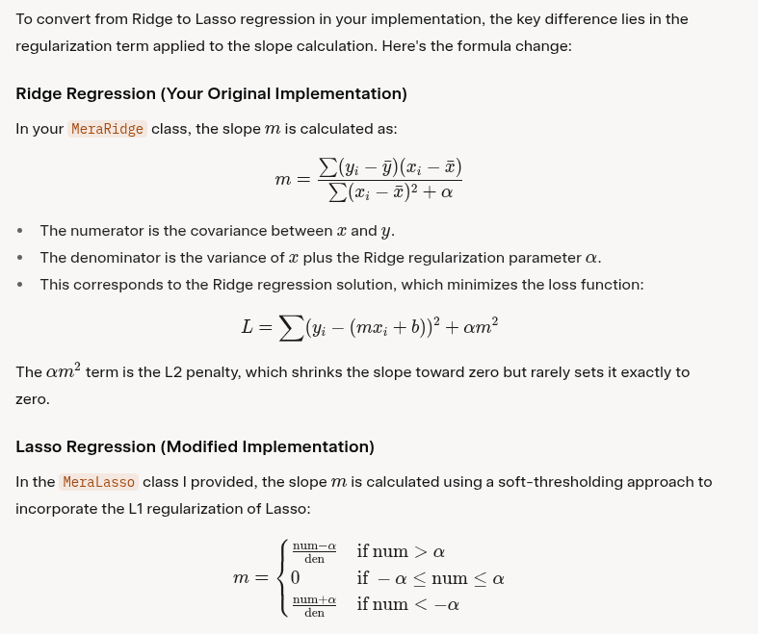

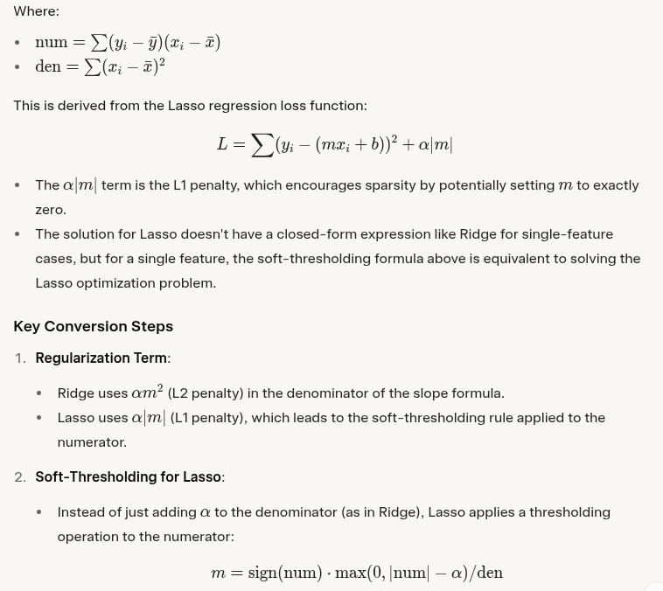
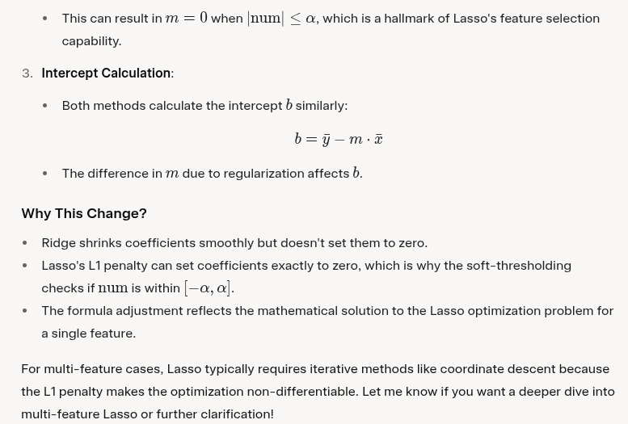

SIMPLE RIDGE REGRESSION

import numpy as np
class MeraRidge:

def __init__(self,alpha=0.1):
self.alpha = alpha
self.m = None
self.b = None

def fit(self,X_train,y_train):

num = 0
den = 0

for i in range(X_train.shape[0]):
num = num + (y_train[i] - y_train.mean())*(X_train[i] - X_train.mean())
den = den + (X_train[i] - X_train.mean())*(X_train[i] - X_train.mean())

self.m = num/(den + self.alpha)
self.b = y_train.mean() - (self.m*X_train.mean())
print(self.m,self.b)

def predict(self, X_test):
return np.dot( X_test,self.m) + self.b

RIDGE REGRESSION GRADIENT DESCENT

class MeraRidgeGD:

def __init__(self,epochs,learning_rate,alpha):

self.learning_rate = learning_rate
self.epochs = epochs
self.alpha = alpha
self.coef_ = None
self.intercept_ = None

def fit(self,X_train,y_train):

self.coef_ = np.ones(X_train.shape[1])
self.intercept_ = 0
thetha = np.insert(self.coef_,0,self.intercept_)

X_train = np.insert(X_train,0,1,axis=1)

for i in range(self.epochs):
thetha_der = np.dot(X_train.T,X_train).dot(thetha) - np.dot(X_train.T,y_train) + self.alpha*thetha
thetha = thetha - self.learning_rate*thetha_der

self.coef_ = thetha[1:]
self.intercept_ = thetha[0]

def predict(self,X_test):

return np.dot(X_test,self.coef_) + self.intercept_

LASSO REGRESSION OLS Simple

import numpy as np

class MeraLasso:

def __init__(self, alpha=0.1):
self.alpha = alpha
self.m = None
self.b = None

def fit(self, X_train, y_train):
# For simplicity, implementing for single feature
num = 0
den = 0

for i in range(X_train.shape[0]):
num = num + (y_train[i] - y_train.mean())*(X_train[i] - X_train.mean())
den = den + (X_train[i] - X_train.mean())*(X_train[i] - X_train.mean())

# Lasso modification: apply soft-thresholding
self.m = max(0, num - self.alpha) / den if num > self.alpha else min(0, num + self.alpha) / den
self.b = y_train.mean() - (self.m * X_train.mean())
print(f"Slope (m): {self.m}, Intercept (b): {self.b}")

def predict(self, X_test):
return np.dot(X_test, self.m) + self.b

OLS MULTIPLE LASSO
import numpy as np

class MeraLassoMulti:

def __init__(self, alpha=0.1):
self.alpha = alpha
self.m = None
self.b = None

def fit(self, X_train, y_train):
n_samples, n_features = X_train.shape
self.m = np.zeros(n_features)
self.b = y_train.mean()

# Simple coordinate descent
for _ in range(1000): # Fixed iterations for simplicity
m_old = self.m.copy()

# Update each coefficient
for j in range(n_features):
# Compute residual excluding current feature's contribution
residual = y_train - np.dot(X_train, self.m) - self.b + self.m[j] * X_train[:, j]
# Compute numerator and denominator
num = np.sum(residual * X_train[:, j])
den = np.sum(X_train[:, j] ** 2)
# Soft-thresholding for Lasso
if num > self.alpha:
self.m[j] = (num - self.alpha) / den
elif num < -self.alpha:
self.m[j] = (num + self.alpha) / den
else:
self.m[j] = 0

# Update intercept
self.b = np.mean(y_train - np.dot(X_train, self.m))

# Check for convergence (simple check)
if np.all(np.abs(self.m - m_old) < 1e-4):
break

print(f"Slope (m): {self.m}, Intercept (b): {self.b}")

def predict(self, X_test):
return np.dot(X_test, self.m) + self.b

GD LASSO SIMPLE-MULTIPLE

import numpy as np

class MeraLassoGD:

def __init__(self, epochs, learning_rate, alpha):
self.learning_rate = learning_rate
self.epochs = epochs
self.alpha = alpha
self.coef_ = None
self.intercept_ = None

def fit(self, X_train, y_train):
# Initialize coefficients and intercept
self.coef_ = np.ones(X_train.shape[1])
self.intercept_ = 0
theta = np.insert(self.coef_, 0, self.intercept_)

# Add column of ones to X_train for intercept
X_train = np.insert(X_train, 0, 1, axis=1)

# Gradient descent
for i in range(self.epochs):
# Compute predictions
y_pred = np.dot(X_train, theta)
# Compute gradient of MSE term
mse_grad = np.dot(X_train.T, (y_pred - y_train)) / X_train.shape[0]
# Compute subgradient of L1 penalty for coefficients (excluding intercept)
l1_grad = np.zeros_like(theta)
l1_grad[1:] = self.alpha * np.sign(theta[1:]) # Subgradient of |theta_j| is sign(theta_j)
# Total gradient
theta_der = mse_grad + l1_grad
# Update parameters
theta = theta - self.learning_rate * theta_der

# Store final coefficients and intercept
self.coef_ = theta[1:]
self.intercept_ = theta[0]
print(f"Coefficients: {self.coef_}, Intercept: {self.intercept_}")

def predict(self, X_test):
return np.dot(X_test, self.coef_) + self.intercept_

ELASTIC NET GD

import numpy as np

class MeraElasticNetGD:

def __init__(self, epochs, learning_rate, alpha, l1_ratio):
self.learning_rate = learning_rate
self.epochs = epochs
self.alpha = alpha # Total regularization strength
self.l1_ratio = l1_ratio # Balance between L1 and L2 (0 <= l1_ratio <= 1)
self.coef_ = None
self.intercept_ = None

def fit(self, X_train, y_train):
# Initialize coefficients and intercept
self.coef_ = np.ones(X_train.shape[1])
self.intercept_ = 0
theta = np.insert(self.coef_, 0, self.intercept_)

# Add column of ones to X_train for intercept
X_train = np.insert(X_train, 0, 1, axis=1)

# Gradient descent
for i in range(self.epochs):
# Compute predictions
y_pred = np.dot(X_train, theta)
# Compute gradient of MSE term
mse_grad = np.dot(X_train.T, (y_pred - y_train)) / X_train.shape[0]
# Compute subgradient of L1 penalty for coefficients (excluding intercept)
l1_grad = np.zeros_like(theta)
l1_grad[1:] = self.alpha * self.l1_ratio * np.sign(theta[1:]) # L1 subgradient
# Compute gradient of L2 penalty for coefficients (excluding intercept)
l2_grad = np.zeros_like(theta)
l2_grad[1:] = self.alpha * (1 - self.l1_ratio) * theta[1:] # L2 gradient
# Total gradient
theta_der = mse_grad + l1_grad + l2_grad
# Update parameters
theta = theta - self.learning_rate * theta_der

# Store final coefficients and intercept
self.coef_ = theta[1:]
self.intercept_ = theta[0]
print(f"Coefficients: {self.coef_}, Intercept: {self.intercept_}")

def predict(self, X_test):
return np.dot(X_test, self.coef_) + self.intercept_

LOGISTIC REGRESSION

import numpy as np

class LogisticRegression:
def __init__(self, learning_rate=0.01, max_iterations=1000, tolerance=1e-6):
self.learning_rate = learning_rate
self.max_iterations = max_iterations
self.tolerance = tolerance
self.weights = None
self.bias = None
self.cost_history = []

def _add_intercept(self, X):
"""Add bias column to the feature matrix"""
intercept = np.ones((X.shape[0], 1))
return np.concatenate((intercept, X), axis=1)

def _sigmoid(self, z):
"""Sigmoid activation function with numerical stability"""
z = np.clip(z, -500, 500) # Prevent overflow
return 1 / (1 + np.exp(-z))

def _cost_function(self, h, y):
"""Calculate logistic regression cost function"""
# Add small epsilon to prevent log(0)
epsilon = 1e-15
h = np.clip(h, epsilon, 1 - epsilon)
return (-y * np.log(h) - (1 - y) * np.log(1 - h)).mean()

def fit(self, X, y):
"""Train the logistic regression model"""
# Add intercept term
X = self._add_intercept(X)

# Initialize weights
self.weights = np.zeros(X.shape[1])

# Gradient descent
for i in range(self.max_iterations):
# Forward propagation
z = np.dot(X, self.weights)
h = self._sigmoid(z)

# Calculate cost
cost = self._cost_function(h, y)
self.cost_history.append(cost)

# Calculate gradient
gradient = np.dot(X.T, (h - y)) / y.size

# Update weights
new_weights = self.weights - self.learning_rate * gradient

# Check for convergence
if np.linalg.norm(new_weights - self.weights) < self.tolerance:
print(f"Converged after {i+1} iterations")
break

self.weights = new_weights

# Separate bias and weights for easier interpretation
self.bias = self.weights[0]
self.weights = self.weights[1:]

def predict_proba(self, X):
"""Predict class probabilities"""
X = self._add_intercept(X)
weights_with_bias = np.concatenate([[self.bias], self.weights])
return self._sigmoid(np.dot(X, weights_with_bias))

def predict(self, X, threshold=0.5):
"""Make binary predictions"""
return (self.predict_proba(X) >= threshold).astype(int)

def score(self, X, y):
"""Calculate accuracy score"""
predictions = self.predict(X)
return (predictions == y).mean()

# Example usage:
if __name__ == "__main__":
# Generate sample data
np.random.seed(42)
m, n = 1000, 2
X = np.random.randn(m, n)
y = (X[:, 0] + X[:, 1] + np.random.randn(m) * 0.1 > 0).astype(int)

# Train model
model = LogisticRegression(learning_rate=0.1, max_iterations=1000)
model.fit(X, y)

# Make predictions
predictions = model.predict(X)
probabilities = model.predict_proba(X)
accuracy = model.score(X, y)

print(f"Final weights: {model.weights}")
print(f"Final bias: {model.bias}")
print(f"Accuracy: {accuracy:.4f}")
print(f"Final cost: {model.cost_history[-1]:.6f}")

import numpy as np

class LogisticRegressionLasso:
def __init__(self, learning_rate=0.01, max_iterations=1000, tolerance=1e-6, alpha=0.01):
self.learning_rate = learning_rate
self.max_iterations = max_iterations
self.tolerance = tolerance
self.alpha = alpha # L1 regularization parameter
self.weights = None
self.bias = None
self.cost_history = []

def _add_intercept(self, X):
"""Add bias column to the feature matrix"""
intercept = np.ones((X.shape[0], 1))
return np.concatenate((intercept, X), axis=1)

def _sigmoid(self, z):
"""Sigmoid activation function with numerical stability"""
z = np.clip(z, -500, 500)
return 1 / (1 + np.exp(-z))

def _cost_function(self, h, y, weights):
"""Calculate logistic regression cost function with L1 regularization"""
epsilon = 1e-15
h = np.clip(h, epsilon, 1 - epsilon)

# Logistic loss
logistic_loss = (-y * np.log(h) - (1 - y) * np.log(1 - h)).mean()

# L1 penalty (excluding bias term)
l1_penalty = self.alpha * np.sum(np.abs(weights[1:]))

return logistic_loss + l1_penalty

def _soft_threshold(self, x, lambda_val):
"""Soft thresholding operator for L1 regularization"""
return np.sign(x) * np.maximum(np.abs(x) - lambda_val, 0)

def fit(self, X, y):
"""Train the logistic regression model with L1 regularization"""
# Add intercept term
X_with_intercept = self._add_intercept(X)

# Initialize weights
self.weights = np.zeros(X_with_intercept.shape[1])

# Gradient descent with proximal operator for L1
for i in range(self.max_iterations):
# Forward propagation
z = np.dot(X_with_intercept, self.weights)
h = self._sigmoid(z)

# Calculate cost
cost = self._cost_function(h, y, self.weights)
self.cost_history.append(cost)

# Calculate gradient for logistic loss
gradient = np.dot(X_with_intercept.T, (h - y)) / y.size

# Gradient descent step
new_weights = self.weights - self.learning_rate * gradient

# Apply soft thresholding for L1 regularization (except for bias)
new_weights[1:] = self._soft_threshold(
new_weights[1:],
self.learning_rate * self.alpha
)

# Check for convergence
if np.linalg.norm(new_weights - self.weights) < self.tolerance:
print(f"Converged after {i+1} iterations")
break

self.weights = new_weights

# Separate bias and weights
self.bias = self.weights[0]
self.weights = self.weights[1:]

def predict_proba(self, X):
"""Predict class probabilities"""
X_with_intercept = self._add_intercept(X)
weights_with_bias = np.concatenate([[self.bias], self.weights])
return self._sigmoid(np.dot(X_with_intercept, weights_with_bias))

def predict(self, X, threshold=0.5):
"""Make binary predictions"""
return (self.predict_proba(X) >= threshold).astype(int)

def score(self, X, y):
"""Calculate accuracy score"""
predictions = self.predict(X)
return (predictions == y).mean()

def get_feature_importance(self):
"""Get feature importance based on absolute weights"""
return np.abs(self.weights)

# Example usage:
if __name__ == "__main__":
# Generate sample data with some irrelevant features
np.random.seed(42)
m, n = 1000, 5
X = np.random.randn(m, n)
# Only first 2 features are relevant
y = (X[:, 0] + X[:, 1] + np.random.randn(m) * 0.1 > 0).astype(int)

# Train model with different alpha values
alphas = [0.0, 0.01, 0.1, 1.0]

for alpha in alphas:
print(f"\nAlpha = {alpha}")
model = LogisticRegressionLasso(learning_rate=0.1, max_iterations=1000, alpha=alpha)
model.fit(X, y)

accuracy = model.score(X, y)
n_zero_weights = np.sum(np.abs(model.weights) < 1e-4)

print(f"Weights: {model.weights}")
print(f"Bias: {model.bias:.4f}")
print(f"Accuracy: {accuracy:.4f}")
print(f"Number of zero weights: {n_zero_weights}")
print(f"Final cost: {model.cost_history[-1]:.6f}")

import numpy as np

class LogisticRegressionRidge:
def __init__(self, learning_rate=0.01, max_iterations=1000, tolerance=1e-6, alpha=0.01):
self.learning_rate = learning_rate
self.max_iterations = max_iterations
self.tolerance = tolerance
self.alpha = alpha # L2 regularization parameter
self.weights = None
self.bias = None
self.cost_history = []

def _add_intercept(self, X):
"""Add bias column to the feature matrix"""
intercept = np.ones((X.shape[0], 1))
return np.concatenate((intercept, X), axis=1)

def _sigmoid(self, z):
"""Sigmoid activation function with numerical stability"""
z = np.clip(z, -500, 500)
return 1 / (1 + np.exp(-z))

def _cost_function(self, h, y, weights):
"""Calculate logistic regression cost function with L2 regularization"""
epsilon = 1e-15
h = np.clip(h, epsilon, 1 - epsilon)

# Logistic loss
logistic_loss = (-y * np.log(h) - (1 - y) * np.log(1 - h)).mean()

# L2 penalty (excluding bias term)
l2_penalty = self.alpha * 0.5 * np.sum(weights[1:] ** 2)

return logistic_loss + l2_penalty

def fit(self, X, y):
"""Train the logistic regression model with L2 regularization"""
# Add intercept term
X_with_intercept = self._add_intercept(X)

# Initialize weights
self.weights = np.zeros(X_with_intercept.shape[1])

# Gradient descent
for i in range(self.max_iterations):
# Forward propagation
z = np.dot(X_with_intercept, self.weights)
h = self._sigmoid(z)

# Calculate cost
cost = self._cost_function(h, y, self.weights)
self.cost_history.append(cost)

# Calculate gradient
gradient = np.dot(X_with_intercept.T, (h - y)) / y.size

# Add L2 regularization to gradient (except for bias)
l2_gradient = np.zeros_like(self.weights)
l2_gradient[1:] = self.alpha * self.weights[1:]
gradient += l2_gradient

# Update weights
new_weights = self.weights - self.learning_rate * gradient

# Check for convergence
if np.linalg.norm(new_weights - self.weights) < self.tolerance:
print(f"Converged after {i+1} iterations")
break

self.weights = new_weights

# Separate bias and weights
self.bias = self.weights[0]
self.weights = self.weights[1:]

def predict_proba(self, X):
"""Predict class probabilities"""
X_with_intercept = self._add_intercept(X)
weights_with_bias = np.concatenate([[self.bias], self.weights])
return self._sigmoid(np.dot(X_with_intercept, weights_with_bias))

def predict(self, X, threshold=0.5):
"""Make binary predictions"""
return (self.predict_proba(X) >= threshold).astype(int)

def score(self, X, y):
"""Calculate accuracy score"""
predictions = self.predict(X)
return (predictions == y).mean()

def get_feature_importance(self):
"""Get feature importance based on absolute weights"""
return np.abs(self.weights)

# Example usage:
if __name__ == "__main__":
# Generate sample data
np.random.seed(42)
m, n = 1000, 5
X = np.random.randn(m, n)
# Create some correlation between features
X[:, 2] = X[:, 0] + np.random.randn(m) * 0.1
X[:, 3] = X[:, 1] + np.random.randn(m) * 0.1
y = (X[:, 0] + X[:, 1] + np.random.randn(m) * 0.1 > 0).astype(int)

# Train model with different alpha values
alphas = [0.0, 0.01, 0.1, 1.0]

for alpha in alphas:
print(f"\nAlpha = {alpha}")
model = LogisticRegressionRidge(learning_rate=0.1, max_iterations=1000, alpha=alpha)
model.fit(X, y)

accuracy = model.score(X, y)
weight_magnitude = np.linalg.norm(model.weights)

print(f"Weights: {model.weights}")
print(f"Bias: {model.bias:.4f}")
print(f"Accuracy: {accuracy:.4f}")
print(f"Weight magnitude (L2 norm): {weight_magnitude:.4f}")
print(f"Final cost: {model.cost_history[-1]:.6f}")

import numpy as np

class LogisticRegressionElasticNet:
def __init__(self, learning_rate=0.01, max_iterations=1000, tolerance=1e-6,
alpha=0.01, l1_ratio=0.5):
self.learning_rate = learning_rate
self.max_iterations = max_iterations
self.tolerance = tolerance
self.alpha = alpha # Overall regularization strength
self.l1_ratio = l1_ratio # Mix ratio between L1 and L2 (0=Ridge, 1=Lasso)
self.weights = None
self.bias = None
self.cost_history = []

def _add_intercept(self, X):
"""Add bias column to the feature matrix"""
intercept = np.ones((X.shape[0], 1))
return np.concatenate((intercept, X), axis=1)

def _sigmoid(self, z):
"""Sigmoid activation function with numerical stability"""
z = np.clip(z, -500, 500)
return 1 / (1 + np.exp(-z))

def _cost_function(self, h, y, weights):
"""Calculate logistic regression cost function with Elastic Net regularization"""
epsilon = 1e-15
h = np.clip(h, epsilon, 1 - epsilon)

# Logistic loss
logistic_loss = (-y * np.log(h) - (1 - y) * np.log(1 - h)).mean()

# Elastic Net penalty (excluding bias term)
l1_penalty = self.l1_ratio * np.sum(np.abs(weights[1:]))
l2_penalty = (1 - self.l1_ratio) * 0.5 * np.sum(weights[1:] ** 2)
elastic_penalty = self.alpha * (l1_penalty + l2_penalty)

return logistic_loss + elastic_penalty

def _soft_threshold(self, x, lambda_val):
"""Soft thresholding operator for L1 regularization"""
return np.sign(x) * np.maximum(np.abs(x) - lambda_val, 0)

def fit(self, X, y):
"""Train the logistic regression model with Elastic Net regularization"""
# Add intercept term
X_with_intercept = self._add_intercept(X)

# Initialize weights
self.weights = np.zeros(X_with_intercept.shape[1])

# Calculate L1 and L2 coefficients
l1_coef = self.alpha * self.l1_ratio
l2_coef = self.alpha * (1 - self.l1_ratio)

# Gradient descent with elastic net regularization
for i in range(self.max_iterations):
# Forward propagation
z = np.dot(X_with_intercept, self.weights)
h = self._sigmoid(z)

# Calculate cost
cost = self._cost_function(h, y, self.weights)
self.cost_history.append(cost)

# Calculate gradient for logistic loss
gradient = np.dot(X_with_intercept.T, (h - y)) / y.size

# Add L2 regularization to gradient (except for bias)
l2_gradient = np.zeros_like(self.weights)
l2_gradient[1:] = l2_coef * self.weights[1:]
gradient += l2_gradient

# Gradient descent step
new_weights = self.weights - self.learning_rate * gradient

# Apply soft thresholding for L1 regularization (except for bias)
new_weights[1:] = self._soft_threshold(
new_weights[1:],
self.learning_rate * l1_coef
)

# Check for convergence
if np.linalg.norm(new_weights - self.weights) < self.tolerance:
print(f"Converged after {i+1} iterations")
break

self.weights = new_weights

# Separate bias and weights
self.bias = self.weights[0]
self.weights = self.weights[1:]

def predict_proba(self, X):
"""Predict class probabilities"""
X_with_intercept = self._add_intercept(X)
weights_with_bias = np.concatenate([[self.bias], self.weights])
return self._sigmoid(np.dot(X_with_intercept, weights_with_bias))

def predict(self, X, threshold=0.5):
"""Make binary predictions"""
return (self.predict_proba(X) >= threshold).astype(int)

def score(self, X, y):
"""Calculate accuracy score"""
predictions = self.predict(X)
return (predictions == y).mean()

def get_feature_importance(self):
"""Get feature importance based on absolute weights"""
return np.abs(self.weights)

# Example usage:
if __name__ == "__main__":
# Generate sample data with correlated and irrelevant features
np.random.seed(42)
m, n = 1000, 6
X = np.random.randn(m, n)

# Create correlation between some features
X[:, 2] = X[:, 0] + np.random.randn(m) * 0.1 # Correlated with feature 0
X[:, 3] = X[:, 1] + np.random.randn(m) * 0.1 # Correlated with feature 1
# Features 4 and 5 are irrelevant noise

# Only first 2 features are truly relevant
y = (X[:, 0] + X[:, 1] + np.random.randn(m) * 0.1 > 0).astype(int)

# Train model with different l1_ratio values
l1_ratios = [0.0, 0.3, 0.5, 0.7, 1.0] # 0=Ridge, 1=Lasso

for l1_ratio in l1_ratios:
print(f"\nL1 ratio = {l1_ratio} (0=Ridge, 1=Lasso)")
model = LogisticRegressionElasticNet(
learning_rate=0.1,
max_iterations=1000,
alpha=0.1,
l1_ratio=l1_ratio
)
model.fit(X, y)

accuracy = model.score(X, y)
n_zero_weights = np.sum(np.abs(model.weights) < 1e-4)
weight_magnitude = np.linalg.norm(model.weights)

print(f"Weights: {model.weights}")
print(f"Bias: {model.bias:.4f}")
print(f"Accuracy: {accuracy:.4f}")
print(f"Number of near-zero weights: {n_zero_weights}")
print(f"Weight magnitude (L2 norm): {weight_magnitude:.4f}")
print(f"Final cost: {model.cost_history[-1]:.6f}")

# Demonstrate the effect of different alpha values with fixed l1_ratio
print(f"\n{'='*50}")
print("Effect of different alpha values (l1_ratio=0.5)")
alphas = [0.01, 0.1, 0.5, 1.0]

for alpha in alphas:
print(f"\nAlpha = {alpha}")
model = LogisticRegressionElasticNet(
learning_rate=0.1,
max_iterations=1000,
alpha=alpha,
l1_ratio=0.5
)
model.fit(X, y)

accuracy = model.score(X, y)
n_zero_weights = np.sum(np.abs(model.weights) < 1e-4)

print(f"Weights: {model.weights}")
print(f"Accuracy: {accuracy:.4f}")
print(f"Number of near-zero weights: {n_zero_weights}")

KMEANS CLUSTERING

import numpy as np
import matplotlib.pyplot as plt
from collections import defaultdict

class KMeansClusterer:
def __init__(self, k=3, max_iterations=100, tolerance=1e-6,
init_method='k-means++', random_state=None):
"""
K-Means Clustering Algorithm

Parameters:
-----------
k : int, default=3
Number of clusters
max_iterations : int, default=100
Maximum number of iterations
tolerance : float, default=1e-6
Tolerance for convergence
init_method : str, default='k-means++'
Initialization method ('random', 'k-means++')
random_state : int, default=None
Random seed for reproducibility
"""
self.k = k
self.max_iterations = max_iterations
self.tolerance = tolerance
self.init_method = init_method
self.random_state = random_state

# Model attributes
self.centroids = None
self.labels = None
self.inertia = None
self.n_iterations = 0
self.centroid_history = []
self.inertia_history = []

# Set random seed if provided
if random_state is not None:
np.random.seed(random_state)

def _euclidean_distance(self, point1, point2):
"""Calculate Euclidean distance between two points"""
return np.sqrt(np.sum((point1 - point2) ** 2, axis=1))

def _initialize_centroids_random(self, X):
"""Initialize centroids randomly"""
n_samples, n_features = X.shape
centroids = np.zeros((self.k, n_features))

for i in range(self.k):
# Random initialization within data bounds
centroids[i] = np.random.uniform(
X.min(axis=0), X.max(axis=0), n_features
)

return centroids

def _initialize_centroids_kmeans_plus_plus(self, X):
"""Initialize centroids using k-means++ method"""
n_samples, n_features = X.shape
centroids = np.zeros((self.k, n_features))

# Choose first centroid randomly
centroids[0] = X[np.random.randint(n_samples)]

# Choose remaining centroids
for i in range(1, self.k):
# Calculate distances from each point to nearest centroid
distances = np.array([
min([self._euclidean_distance(x.reshape(1, -1), c.reshape(1, -1))[0]
for c in centroids[:i]])
for x in X
])

# Choose next centroid with probability proportional to squared distance
probabilities = distances ** 2
probabilities /= probabilities.sum()

cumulative_probs = probabilities.cumsum()
r = np.random.rand()

for j, p in enumerate(cumulative_probs):
if r < p:
centroids[i] = X[j]
break

return centroids

def _assign_clusters(self, X):
"""Assign each point to the nearest centroid"""
distances = np.zeros((X.shape[0], self.k))

for i, centroid in enumerate(self.centroids):
distances[:, i] = self._euclidean_distance(X, centroid.reshape(1, -1))

return np.argmin(distances, axis=1)

def _update_centroids(self, X, labels):
"""Update centroids to the mean of assigned points"""
new_centroids = np.zeros((self.k, X.shape[1]))

for i in range(self.k):
cluster_points = X[labels == i]
if len(cluster_points) > 0:
new_centroids[i] = cluster_points.mean(axis=0)
else:
# If no points assigned to cluster, keep current centroid
new_centroids[i] = self.centroids[i]

return new_centroids

def _calculate_inertia(self, X, labels):
"""Calculate within-cluster sum of squares (inertia)"""
inertia = 0
for i in range(self.k):
cluster_points = X[labels == i]
if len(cluster_points) > 0:
centroid = self.centroids[i]
inertia += np.sum((cluster_points - centroid) ** 2)
return inertia

def fit(self, X):
"""
Fit K-means clustering to data

Parameters:
-----------
X : array-like, shape (n_samples, n_features)
Training data
"""
X = np.array(X)
n_samples, n_features = X.shape

if self.k > n_samples:
raise ValueError(f"k={self.k} cannot be larger than number of samples={n_samples}")

# Initialize centroids
if self.init_method == 'random':
self.centroids = self._initialize_centroids_random(X)
elif self.init_method == 'k-means++':
self.centroids = self._initialize_centroids_kmeans_plus_plus(X)
else:
raise ValueError(f"Unknown initialization method: {self.init_method}")

# Store initial centroids
self.centroid_history = [self.centroids.copy()]

# Main K-means loop
for iteration in range(self.max_iterations):
# Assign points to clusters
labels = self._assign_clusters(X)

# Update centroids
new_centroids = self._update_centroids(X, labels)

# Calculate inertia
inertia = self._calculate_inertia(X, labels)
self.inertia_history.append(inertia)

# Check for convergence
centroid_shift = np.sqrt(np.sum((new_centroids - self.centroids) ** 2))

if centroid_shift < self.tolerance:
print(f"Converged after {iteration + 1} iterations")
break

# Update centroids
self.centroids = new_centroids
self.centroid_history.append(self.centroids.copy())

self.n_iterations = iteration + 1
self.labels = labels
self.inertia = inertia

print(f"K-means clustering completed:")
print(f" Number of clusters: {self.k}")
print(f" Iterations: {self.n_iterations}")
print(f" Final inertia: {self.inertia:.4f}")
print(f" Initialization method: {self.init_method}")

def predict(self, X):
"""
Predict cluster labels for new data

Parameters:
-----------
X : array-like, shape (n_samples, n_features)
Data to predict

Returns:
--------
labels : array, shape (n_samples,)
Cluster labels
"""
if self.centroids is None:
raise ValueError("Model has not been fitted yet. Call fit() first.")

X = np.array(X)
if X.ndim == 1:
X = X.reshape(1, -1)

return self._assign_clusters(X)

def fit_predict(self, X):
"""Fit the model and predict cluster labels"""
self.fit(X)
return self.labels

def get_cluster_centers(self):
"""Get cluster centroids"""
if self.centroids is None:
raise ValueError("Model has not been fitted yet. Call fit() first.")
return self.centroids.copy()

def get_cluster_info(self, X):
"""Get detailed information about each cluster"""
if self.centroids is None:
raise ValueError("Model has not been fitted yet. Call fit() first.")

X = np.array(X)
cluster_info = {}

for i in range(self.k):
cluster_points = X[self.labels == i]
cluster_info[i] = {
'centroid': self.centroids[i],
'size': len(cluster_points),
'percentage': len(cluster_points) / len(X) * 100,
'intra_cluster_distance': np.mean([
self._euclidean_distance(point.reshape(1, -1),
self.centroids[i].reshape(1, -1))[0]
for point in cluster_points
]) if len(cluster_points) > 0 else 0
}

return cluster_info

def silhouette_score(self, X):
"""Calculate silhouette score for the clustering"""
if self.centroids is None:
raise ValueError("Model has not been fitted yet. Call fit() first.")

X = np.array(X)
n_samples = X.shape[0]
silhouette_scores = np.zeros(n_samples)

for i in range(n_samples):
# Points in same cluster
same_cluster = X[self.labels == self.labels[i]]

if len(same_cluster) == 1:
silhouette_scores[i] = 0
continue

# Average distance to points in same cluster
a = np.mean([self._euclidean_distance(X[i].reshape(1, -1),
point.reshape(1, -1))[0]
for point in same_cluster if not np.array_equal(point, X[i])])

# Average distance to points in nearest different cluster
b_scores = []
for cluster_id in range(self.k):
if cluster_id != self.labels[i]:
other_cluster = X[self.labels == cluster_id]
if len(other_cluster) > 0:
avg_dist = np.mean([
self._euclidean_distance(X[i].reshape(1, -1),
point.reshape(1, -1))[0]
for point in other_cluster
])
b_scores.append(avg_dist)

if b_scores:
b = min(b_scores)
silhouette_scores[i] = (b - a) / max(a, b)

return np.mean(silhouette_scores)

def elbow_method(self, X, k_range=None):
"""
Perform elbow method to find optimal number of clusters

Parameters:
-----------
X : array-like, shape (n_samples, n_features)
Data
k_range : range or list, default=None
Range of k values to try. If None, uses range(1, 11)

Returns:
--------
k_values : list
K values tested
inertias : list
Inertia values for each k
"""
if k_range is None:
k_range = range(1, min(11, len(X)))

k_values = []
inertias = []

original_k = self.k

for k in k_range:
self.k = k
self.fit(X)
k_values.append(k)
inertias.append(self.inertia)

# Restore original k
self.k = original_k

return k_values, inertias

def plot_clusters(self, X, feature_indices=(0, 1), figsize=(10, 8)):
"""
Plot clusters (works for 2D visualization)

Parameters:
-----------
X : array-like, shape (n_samples, n_features)
Data
feature_indices : tuple, default=(0, 1)
Indices of features to plot
figsize : tuple, default=(10, 8)
Figure size
"""
if self.centroids is None:
raise ValueError

SOFTMAX REGRESSION

import numpy as np
from collections import Counter

class SoftmaxRegression:
def __init__(self, learning_rate=0.01, max_iterations=1000, tolerance=1e-6,
regularization=None, alpha=0.01):
self.learning_rate = learning_rate
self.max_iterations = max_iterations
self.tolerance = tolerance
self.regularization = regularization # None, 'l1', 'l2', or 'elastic_net'
self.alpha = alpha # Regularization strength
self.weights = None
self.bias = None
self.n_classes = None
self.classes = None
self.cost_history = []

def _add_intercept(self, X):
"""Add bias column to the feature matrix"""
intercept = np.ones((X.shape[0], 1))
return np.concatenate((intercept, X), axis=1)

def _softmax(self, z):
"""
Compute softmax function with numerical stability
z: (n_samples, n_classes)
"""
# Subtract max for numerical stability
z_shifted = z - np.max(z, axis=1, keepdims=True)
exp_z = np.exp(z_shifted)
return exp_z / np.sum(exp_z, axis=1, keepdims=True)

def _one_hot_encode(self, y):
"""Convert class labels to one-hot encoded matrix"""
n_samples = len(y)
one_hot = np.zeros((n_samples, self.n_classes))
for i, class_idx in enumerate(y):
one_hot[i, class_idx] = 1
return one_hot

def _cross_entropy_loss(self, y_pred, y_true):
"""
Compute cross-entropy loss
y_pred: predicted probabilities (n_samples, n_classes)
y_true: one-hot encoded true labels (n_samples, n_classes)
"""
# Add small epsilon to prevent log(0)
epsilon = 1e-15
y_pred = np.clip(y_pred, epsilon, 1 - epsilon)

# Cross-entropy loss
loss = -np.sum(y_true * np.log(y_pred)) / y_pred.shape[0]

# Add regularization if specified
if self.regularization == 'l1':
loss += self.alpha * np.sum(np.abs(self.weights))
elif self.regularization == 'l2':
loss += self.alpha * 0.5 * np.sum(self.weights ** 2)
elif self.regularization == 'elastic_net':
l1_penalty = 0.5 * np.sum(np.abs(self.weights))
l2_penalty = 0.5 * 0.5 * np.sum(self.weights ** 2)
loss += self.alpha * (l1_penalty + l2_penalty)

return loss

def _compute_gradients(self, X, y_pred, y_true):
"""Compute gradients for weights and bias"""
n_samples = X.shape[0]

# Gradient of cross-entropy loss
dW = np.dot(X.T, (y_pred - y_true)) / n_samples

# Add regularization gradients
if self.regularization == 'l1':
dW[1:] += self.alpha * np.sign(self.weights)
elif self.regularization == 'l2':
dW[1:] += self.alpha * self.weights
elif self.regularization == 'elastic_net':
dW[1:] += self.alpha * (0.5 * np.sign(self.weights) + 0.5 * self.weights)

return dW

def _soft_threshold(self, x, lambda_val):
"""Soft thresholding for L1 regularization"""
return np.sign(x) * np.maximum(np.abs(x) - lambda_val, 0)

def fit(self, X, y):
"""
Train the softmax regression model
X: feature matrix (n_samples, n_features)
y: class labels (n_samples,) - can be integers or strings
"""
# Handle class encoding
self.classes = np.unique(y)
self.n_classes = len(self.classes)

# Create mapping from class labels to indices
class_to_idx = {cls: idx for idx, cls in enumerate(self.classes)}
y_indexed = np.array([class_to_idx[cls] for cls in y])

# Add intercept term
X_with_intercept = self._add_intercept(X)
n_features = X_with_intercept.shape[1]

# Initialize weights (n_features, n_classes)
# Using Xavier/Glorot initialization
self.weights = np.random.normal(0, np.sqrt(2.0 / (n_features + self.n_classes)),
(n_features, self.n_classes))

# Convert labels to one-hot encoding
y_one_hot = self._one_hot_encode(y_indexed)

# Training loop
for iteration in range(self.max_iterations):
# Forward pass
z = np.dot(X_with_intercept, self.weights)
y_pred = self._softmax(z)

# Compute loss
loss = self._cross_entropy_loss(y_pred, y_one_hot)
self.cost_history.append(loss)

# Compute gradients
gradients = self._compute_gradients(X_with_intercept, y_pred, y_one_hot)

# Update weights
new_weights = self.weights - self.learning_rate * gradients

# Apply soft thresholding for L1 regularization
if self.regularization == 'l1':
new_weights[1:] = self._soft_threshold(
new_weights[1:],
self.learning_rate * self.alpha
)

# Check for convergence
if np.linalg.norm(new_weights - self.weights) < self.tolerance:
print(f"Converged after {iteration + 1} iterations")
break

self.weights = new_weights

# Separate bias and weights for easier interpretation
self.bias = self.weights[0, :]
self.weights = self.weights[1:, :]

print(f"Training completed. Final loss: {self.cost_history[-1]:.6f}")

def predict_proba(self, X):
"""
Predict class probabilities
Returns: probabilities for each class (n_samples, n_classes)
"""
X_with_intercept = self._add_intercept(X)
weights_with_bias = np.vstack([self.bias.reshape(1, -1), self.weights])
z = np.dot(X_with_intercept, weights_with_bias)
return self._softmax(z)

def predict(self, X):
"""
Make class predictions
Returns: predicted class labels
"""
probabilities = self.predict_proba(X)
predicted_indices = np.argmax(probabilities, axis=1)
return self.classes[predicted_indices]

def score(self, X, y):
"""Calculate accuracy score"""
predictions = self.predict(X)
return np.mean(predictions == y)

def get_feature_importance(self):
"""
Get feature importance for each class
Returns: (n_features, n_classes) array
"""
return np.abs(self.weights)

def classification_report(self, X, y):
"""Generate a detailed classification report"""
predictions = self.predict(X)
probabilities = self.predict_proba(X)

print("Classification Report:")
print("=" * 50)

# Overall accuracy
accuracy = self.score(X, y)
print(f"Overall Accuracy: {accuracy:.4f}")
print()

# Per-class metrics
for i, class_name in enumerate(self.classes):
class_mask = (y == class_name)
pred_mask = (predictions == class_name)

# True positives, false positives, false negatives
tp = np.sum(class_mask & pred_mask)
fp = np.sum(~class_mask & pred_mask)
fn = np.sum(class_mask & ~pred_mask)

# Precision, Recall, F1-score
precision = tp / (tp + fp) if (tp + fp) > 0 else 0
recall = tp / (tp + fn) if (tp + fn) > 0 else 0
f1 = 2 * (precision * recall) / (precision + recall) if (precision + recall) > 0 else 0

# Average probability for this class
avg_prob = np.mean(probabilities[class_mask, i]) if np.sum(class_mask) > 0 else 0

print(f"Class '{class_name}':")
print(f" Precision: {precision:.4f}")
print(f" Recall: {recall:.4f}")
print(f" F1-score: {f1:.4f}")
print(f" Average probability: {avg_prob:.4f}")
print(f" Support: {np.sum(class_mask)}")
print()

# Example usage with different datasets
if __name__ == "__main__":
# Example 1: Iris-like dataset (3 classes)
print("Example 1: Multi-class classification (3 classes)")
print("=" * 50)

np.random.seed(42)
n_samples, n_features = 500, 4
n_classes = 3

# Generate synthetic data
X = np.random.randn(n_samples, n_features)

# Create class-specific patterns
true_weights = np.random.randn(n_features, n_classes)
z = np.dot(X, true_weights) + np.random.randn(n_samples, n_classes) * 0.1
y_prob = np.exp(z - np.max(z, axis=1, keepdims=True))
y_prob = y_prob / np.sum(y_prob, axis=1, keepdims=True)
y = np.array(['Class_A', 'Class_B', 'Class_C'])[np.argmax(y_prob, axis=1)]

# Train model without regularization
model = SoftmaxRegression(learning_rate=0.1, max_iterations=1000)
model.fit(X, y)

# Evaluate
train_accuracy = model.score(X, y)
print(f"Training Accuracy: {train_accuracy:.4f}")

# Show predictions for first 10 samples
predictions = model.predict(X[:10])
probabilities = model.predict_proba(X[:10])

print("\nFirst 10 predictions:")
for i in range(10):
true_class = y[i]
pred_class = predictions[i]
max_prob = np.max(probabilities[i])
print(f"Sample {i+1}: True={true_class}, Pred={pred_class}, Confidence={max_prob:.3f}")

model.classification_report(X, y)

# Example 2: Compare different regularization methods
print("\n" + "="*70)
print("Example 2: Effect of different regularization methods")
print("="*70)

regularizations = [None, 'l1', 'l2', 'elastic_net']

for reg in regularizations:
print(f"\nRegularization: {reg if reg else 'None'}")
print("-" * 30)

model = SoftmaxRegression(
learning_rate=0.1,
max_iterations=500,
regularization=reg,
alpha=0.01
)
model.fit(X, y)

accuracy = model.score(X, y)
n_near_zero_weights = np.sum(np.abs(model.weights) < 1e-4)
weight_magnitude = np.linalg.norm(model.weights)

print(f"Accuracy: {accuracy:.4f}")
print(f"Near-zero weights: {n_near_zero_weights}")
print(f"Weight magnitude: {weight_magnitude:.4f}")
print(f"Final loss: {model.cost_history[-1]:.6f}")

# Example 3: Handling string class labels
print("\n" + "="*70)
print("Example 3: Different types of class labels")
print("="*70)

# Create dataset with string labels
np.random.seed(123)
X_str = np.random.randn(200, 3)
categories = ['Dog', 'Cat', 'Bird', 'Fish']
y_str = np.random.choice(categories, 200)

model_str = SoftmaxRegression(learning_rate=0.1, max_iterations=300)
model_str.fit(X_str, y_str)

print(f"Classes found: {model_str.classes}")
print(f"Number of classes: {model_str.n_classes}")
print(f"Accuracy: {model_str.score(X_str, y_str):.4f}")

# Show class distribution
print(f"\nClass distribution:")
unique, counts = np.unique(y_str, return_counts=True)
for cls, count in zip(unique, counts):
print(f" {cls}: {count} samples")

KNN

import numpy as np
from collections import Counter

class KNNClassifier:
def __init__(self, k=5, distance_metric='euclidean', weights='uniform'):
"""
K-Nearest Neighbors Classifier

Parameters:
-----------
k : int, default=5
Number of neighbors to consider
distance_metric : str, default='euclidean'
Distance metric to use ('euclidean', 'manhattan', 'cosine', 'minkowski')
weights : str, default='uniform'
Weight function ('uniform', 'distance')
"""
self.k = k
self.distance_metric = distance_metric
self.weights = weights
self.X_train = None
self.y_train = None
self.classes = None
self.n_classes = None

def _euclidean_distance(self, x1, x2):
"""Calculate Euclidean distance between two points"""
return np.sqrt(np.sum((x1 - x2) ** 2, axis=1))

def _manhattan_distance(self, x1, x2):
"""Calculate Manhattan distance between two points"""
return np.sum(np.abs(x1 - x2), axis=1)

def _cosine_distance(self, x1, x2):
"""Calculate Cosine distance between two points"""
dot_product = np.sum(x1 * x2, axis=1)
norm_x1 = np.sqrt(np.sum(x1 ** 2))
norm_x2 = np.sqrt(np.sum(x2 ** 2, axis=1))
cosine_sim = dot_product / (norm_x1 * norm_x2)
# Convert similarity to distance
return 1 - cosine_sim

def _minkowski_distance(self, x1, x2, p=3):
"""Calculate Minkowski distance between two points"""
return np.sum(np.abs(x1 - x2) ** p, axis=1) ** (1/p)

def _calculate_distances(self, x_test):
"""Calculate distances from test point to all training points"""
if self.distance_metric == 'euclidean':
return self._euclidean_distance(x_test, self.X_train)
elif self.distance_metric == 'manhattan':
return self._manhattan_distance(x_test, self.X_train)
elif self.distance_metric == 'cosine':
return self._cosine_distance(x_test, self.X_train)
elif self.distance_metric == 'minkowski':
return self._minkowski_distance(x_test, self.X_train)
else:
raise ValueError(f"Unknown distance metric: {self.distance_metric}")

def _get_neighbors(self, x_test):
"""Get k nearest neighbors for a test point"""
distances = self._calculate_distances(x_test)
k_indices = np.argsort(distances)[:self.k]
return k_indices, distances[k_indices]

def _predict_single(self, x_test):
"""Predict class for a single test point"""
neighbor_indices, neighbor_distances = self._get_neighbors(x_test)
neighbor_labels = self.y_train[neighbor_indices]

if self.weights == 'uniform':
# Simple majority vote
prediction = Counter(neighbor_labels).most_common(1)[0][0]

elif self.weights == 'distance':
# Weight by inverse distance
# Add small epsilon to avoid division by zero
epsilon = 1e-8
weights = 1 / (neighbor_distances + epsilon)

# Calculate weighted votes for each class
class_weights = {}
for label, weight in zip(neighbor_labels, weights):
if label in class_weights:
class_weights[label] += weight
else:
class_weights[label] = weight

# Get class with highest weighted vote
prediction = max(class_weights, key=class_weights.get)

return prediction

def _predict_proba_single(self, x_test):
"""Predict class probabilities for a single test point"""
neighbor_indices, neighbor_distances = self._get_neighbors(x_test)
neighbor_labels = self.y_train[neighbor_indices]

# Initialize probabilities for all classes
class_probs = np.zeros(self.n_classes)

if self.weights == 'uniform':
# Count votes for each class
for label in neighbor_labels:
class_idx = np.where(self.classes == label)[0][0]
class_probs[class_idx] += 1
# Normalize
class_probs = class_probs / self.k

elif self.weights == 'distance':
# Weight by inverse distance
epsilon = 1e-8
weights = 1 / (neighbor_distances + epsilon)

# Calculate weighted votes
for label, weight in zip(neighbor_labels, weights):
class_idx = np.where(self.classes == label)[0][0]
class_probs[class_idx] += weight

# Normalize
class_probs = class_probs / np.sum(class_probs)

return class_probs

def fit(self, X, y):
"""
Fit the KNN classifier

Parameters:
-----------
X : array-like, shape (n_samples, n_features)
Training data
y : array-like, shape (n_samples,)
Target values
"""
self.X_train = np.array(X)
self.y_train = np.array(y)
self.classes = np.unique(y)
self.n_classes = len(self.classes)

print(f"KNN Classifier fitted with {len(X)} samples, {X.shape[1]} features")
print(f"Classes: {self.classes}")
print(f"Using k={self.k}, distance='{self.distance_metric}', weights='{self.weights}'")

def predict(self, X):
"""
Predict class labels for test data

Parameters:
-----------
X : array-like, shape (n_samples, n_features)
Test data

Returns:
--------
predictions : array, shape (n_samples,)
Predicted class labels
"""
if self.X_train is None:
raise ValueError("Model has not been fitted yet. Call fit() first.")

X = np.array(X)
if X.ndim == 1:
X = X.reshape(1, -1)

predictions = []
for x_test in X:
pred = self._predict_single(x_test)
predictions.append(pred)

return np.array(predictions)

def predict_proba(self, X):
"""
Predict class probabilities for test data

Parameters:
-----------
X : array-like, shape (n_samples, n_features)
Test data

Returns:
--------
probabilities : array, shape (n_samples, n_classes)
Predicted class probabilities
"""
if self.X_train is None:
raise ValueError("Model has not been fitted yet. Call fit() first.")

X = np.array(X)
if X.ndim == 1:
X = X.reshape(1, -1)

probabilities = []
for x_test in X:
proba = self._predict_proba_single(x_test)
probabilities.append(proba)

return np.array(probabilities)

def score(self, X, y):
"""Calculate accuracy score"""
predictions = self.predict(X)
return np.mean(predictions == y)

def get_neighbors(self, X, return_distance=False):
"""
Get k nearest neighbors indices for test data

Parameters:
-----------
X : array-like, shape (n_samples, n_features)
Test data
return_distance : bool, default=False
Whether to return distances along with indices

Returns:
--------
neighbors : array or tuple
Neighbor indices, and distances if return_distance=True
"""
if self.X_train is None:
raise ValueError("Model has not been fitted yet. Call fit() first.")

X = np.array(X)
if X.ndim == 1:
X = X.reshape(1, -1)

all_neighbors = []
all_distances = []

for x_test in X:
neighbor_indices, neighbor_distances = self._get_neighbors(x_test)
all_neighbors.append(neighbor_indices)
all_distances.append(neighbor_distances)

neighbors = np.array(all_neighbors)
distances = np.array(all_distances)

if return_distance:
return neighbors, distances
else:
return neighbors

def classification_report(self, X, y):
"""Generate detailed classification report"""
predictions = self.predict(X)
probabilities = self.predict_proba(X)

print("KNN Classification Report")
print("=" * 50)
print(f"Test samples: {len(X)}")
print(f"Features: {X.shape[1]}")
print(f"K value: {self.k}")
print(f"Distance metric: {self.distance_metric}")
print(f"Weighting: {self.weights}")
print()

# Overall accuracy
accuracy = self.score(X, y)
print(f"Overall Accuracy: {accuracy:.4f}")
print()

# Per-class metrics
for i, class_name in enumerate(self.classes):
class_mask = (y == class_name)
pred_mask = (predictions == class_name)

tp = np.sum(class_mask & pred_mask)
fp = np.sum(~class_mask & pred_mask)
fn = np.sum(class_mask & ~pred_mask)

precision = tp / (tp + fp) if (tp + fp) > 0 else 0
recall = tp / (tp + fn) if (tp + fn) > 0 else 0
f1 = 2 * (precision * recall) / (precision + recall) if (precision + recall) > 0 else 0

avg_prob = np.mean(probabilities[class_mask, i]) if np.sum(class_mask) > 0 else 0

print(f"Class '{class_name}':")
print(f" Precision: {precision:.4f}")
print(f" Recall: {recall:.4f}")
print(f" F1-score: {f1:.4f}")
print(f" Avg probability: {avg_prob:.4f}")
print(f" Support: {np.sum(class_mask)}")
print()

# Example usage and testing
if __name__ == "__main__":
# Example 1: Basic multi-class classification
print("Example 1: Multi-class classification with synthetic data")
print("=" * 60)

np.random.seed(42)

# Generate synthetic dataset with 3 classes
n_samples_per_class = 100
n_features = 4

# Class 1: centered at (2, 2, 2, 2)
X1 = np.random.randn(n_samples_per_class, n_features) + [2, 2, 2, 2]
y1 = np.full(n_samples_per_class, 'Class_A')

# Class 2: centered at (-2, -2, -2, -2)
X2 = np.random.randn(n_samples_per_class, n_features) + [-2, -2, -2, -2]
y2 = np.full(n_samples_per_class, 'Class_B')

# Class 3: centered at (0, 3, -3, 0)
X3 = np.random.randn(n_samples_per_class, n_features) + [0, 3, -3, 0]
y3 = np.full(n_samples_per_class, 'Class_C')

# Combine data
X = np.vstack([X1, X2, X3])
y = np.hstack([y1, y2, y3])

# Split into train and test
indices = np.random.permutation(len(X))
train_size = int(0.8 * len(X))
train_idx, test_idx = indices[:train_size], indices[train_size:]

X_train, X_test = X[train_idx], X[test_idx]
y_train, y_test = y[train_idx], y[test_idx]

# Test different k values
k_values = [3, 5, 7, 11]

for k in k_values:
print(f"\nTesting with k={k}")
print("-" * 30)

knn = KNNClassifier(k=k, distance_metric='euclidean', weights='uniform')
knn.fit(X_train, y_train)

# Make predictions
predictions = knn.predict(X_test)
probabilities = knn.predict_proba(X_test)
accuracy = knn.score(X_test, y_test)

print(f"Test Accuracy: {accuracy:.4f}")

# Show first 5 predictions
print("First 5 predictions:")
for i in range(min(5, len(X_test))):
true_class = y_test[i]
pred_class = predictions[i]
max_prob = np.max(probabilities[i])
print(f" True: {true_class}, Pred: {pred_class}, Confidence: {max_prob:.3f}")

# Example 2: Compare different distance metrics
print("\n" + "="*60)
print("Example 2: Comparing different distance metrics")
print("="*60)

distance_metrics = ['euclidean', 'manhattan', 'cosine']

for metric in distance_metrics:
print(f"\nDistance metric: {metric}")
print("-" * 30)

knn = KNNClassifier(k=5, distance_metric=metric, weights='uniform')
knn.fit(X_train, y_train)
accuracy = knn.score(X_test, y_test)
print(f"Test Accuracy: {accuracy:.4f}")

# Example 3: Compare uniform vs distance weighting
print("\n" + "="*60)
print("Example 3: Uniform vs Distance weighting")
print("="*60)

for weights in ['uniform', 'distance']:
print(f"\nWeighting: {weights}")
print("-" * 20)

knn = KNNClassifier(k=5, distance_metric='euclidean', weights=weights)
knn.fit(X_train, y_train)
accuracy = knn.score(X_test, y_test)
print(f"Test Accuracy: {accuracy:.4f}")

# Example 4: Detailed classification report
print("\n" + "="*60)
print("Example 4: Detailed Classification Report")
print("="*60)

best_knn = KNNClassifier(k=7, distance_metric='euclidean', weights='distance')
best_knn.fit(X_train, y_train)
best_knn.classification_report(X_test, y_test)

# Example 5: Getting neighbors information
print("Example 5: Neighbor information for first test sample")
print("-" * 50)

neighbors, distances = best_knn.get_neighbors(X_test[:1], return_distance=True)
print(f"Neighbors indices: {neighbors[0]}")
print(f"Distances: {distances[0]}")
print(f"Neighbor classes: {y_train[neighbors[0]]}")

# Example 6: High-dimensional data
print("\n" + "="*60)
print("Example 6: High-dimensional data performance")
print("="*60)

# Generate high-dimensional data
np.random.seed(123)
n_samples, n_features = 200, 20
X_high = np.random.randn(n_samples, n_features)

# Create 4 classes based on different feature combinations
y_high = np.zeros(n_samples, dtype=object)
y_high[:50] = 'A'
y_high[50:100] = 'B'
y_high[100:150] = 'C'
y_high[150:] = 'D'

# Add some pattern to the data
X_high[:50, :5] += 2 # Class A has higher values in first 5 features
X_high[50:100, 5:10] += 2 # Class B has higher values in features 5-10
X_high[100:150, 10:15] += 2 # Class C has higher values in features 10-15
X_high[150:, 15:] += 2 # Class D has higher values in last 5 features

# Split data
train_size = int(0.7 * len(X_high))
X_train_high, X_test_high = X_high[:train_size], X_high[train_size:]
y_train_high, y_test_high = y_high[:train_size], y_high[train_size:]

knn_high = KNNClassifier(k=5, distance_metric='euclidean', weights='distance')
knn_high.fit(X_train_high, y_train_high)
accuracy_high = knn_high.score(X_test_high, y_test_high)

print(f"High-dimensional data accuracy: {accuracy_high:.4f}")
print(f"Data shape: {X_high.shape}")
print(f"Number of classes: {len(np.unique(y_high))}")

DECISION TREE CLASSFIER

class Node():
def __init__(self, feature_index=None, threshold=None, left=None, right=None, info_gain=None, value=None):
''' constructor '''

# for decision node
self.feature_index = feature_index
self.threshold = threshold
self.left = left
self.right = right
self.info_gain = info_gain

# for leaf node
self.value = value

class DecisionTreeClassifier():
def __init__(self, min_samples_split=2, max_depth=2):
''' constructor '''

# initialize the root of the tree
self.root = None

# stopping conditions
self.min_samples_split = min_samples_split
self.max_depth = max_depth

def build_tree(self, dataset, curr_depth=0):
''' recursive function to build the tree '''

X, Y = dataset[:,:-1], dataset[:,-1]
num_samples, num_features = np.shape(X)

# split until stopping conditions are met
if num_samples>=self.min_samples_split and curr_depth<=self.max_depth:
# find the best split
best_split = self.get_best_split(dataset, num_samples, num_features)
# check if information gain is positive
if best_split["info_gain"]>0:
# recur left
left_subtree = self.build_tree(best_split["dataset_left"], curr_depth+1)
# recur right
right_subtree = self.build_tree(best_split["dataset_right"], curr_depth+1)
# return decision node
return Node(best_split["feature_index"], best_split["threshold"],
left_subtree, right_subtree, best_split["info_gain"])

# compute leaf node
leaf_value = self.calculate_leaf_value(Y)
# return leaf node
return Node(value=leaf_value)

def get_best_split(self, dataset, num_samples, num_features):
''' function to find the best split '''

# dictionary to store the best split
best_split = {}
max_info_gain = -float("inf")

# loop over all the features
for feature_index in range(num_features):
feature_values = dataset[:, feature_index]
possible_thresholds = np.unique(feature_values)
# loop over all the feature values present in the data
for threshold in possible_thresholds:
# get current split
dataset_left, dataset_right = self.split(dataset, feature_index, threshold)
# check if childs are not null
if len(dataset_left)>0 and len(dataset_right)>0:
y, left_y, right_y = dataset[:, -1], dataset_left[:, -1], dataset_right[:, -1]
# compute information gain
curr_info_gain = self.information_gain(y, left_y, right_y, "gini")
# update the best split if needed
if curr_info_gain>max_info_gain:
best_split["feature_index"] = feature_index
best_split["threshold"] = threshold
best_split["dataset_left"] = dataset_left
best_split["dataset_right"] = dataset_right
best_split["info_gain"] = curr_info_gain
max_info_gain = curr_info_gain

# return best split
return best_split

def split(self, dataset, feature_index, threshold):
''' function to split the data '''

dataset_left = np.array([row for row in dataset if row[feature_index]<=threshold])
dataset_right = np.array([row for row in dataset if row[feature_index]>threshold])
return dataset_left, dataset_right

def information_gain(self, parent, l_child, r_child, mode="entropy"):
''' function to compute information gain '''

weight_l = len(l_child) / len(parent)
weight_r = len(r_child) / len(parent)
if mode=="gini":
gain = self.gini_index(parent) - (weight_l*self.gini_index(l_child) + weight_r*self.gini_index(r_child))
else:
gain = self.entropy(parent) - (weight_l*self.entropy(l_child) + weight_r*self.entropy(r_child))
return gain

def entropy(self, y):
''' function to compute entropy '''

class_labels = np.unique(y)
entropy = 0
for cls in class_labels:
p_cls = len(y[y == cls]) / len(y)
entropy += -p_cls * np.log2(p_cls)
return entropy

def gini_index(self, y):
''' function to compute gini index '''

class_labels = np.unique(y)
gini = 0
for cls in class_labels:
p_cls = len(y[y == cls]) / len(y)
gini += p_cls**2
return 1 - gini

def calculate_leaf_value(self, Y):
''' function to compute leaf node '''

Y = list(Y)
return max(Y, key=Y.count)

def print_tree(self, tree=None, indent=" "):
''' function to print the tree '''

if not tree:
tree = self.root

if tree.value is not None:
print(tree.value)

else:
print("X_"+str(tree.feature_index), "<=", tree.threshold, "?", tree.info_gain)
print("%sleft:" % (indent), end="")
self.print_tree(tree.left, indent + indent)
print("%sright:" % (indent), end="")
self.print_tree(tree.right, indent + indent)

def fit(self, X, Y):
''' function to train the tree '''

dataset = np.concatenate((X, Y), axis=1)
self.root = self.build_tree(dataset)

def predict(self, X):
''' function to predict new dataset '''

preditions = [self.make_prediction(x, self.root) for x in X]
return preditions

def make_prediction(self, x, tree):
''' function to predict a single data point '''

if tree.value!=None: return tree.value
feature_val = x[tree.feature_index]
if feature_val<=tree.threshold:
return self.make_prediction(x, tree.left)
else:
return self.make_prediction(x, tree.right)

DECISION TREE REGRESSOR

import numpy as np

class Node:
def __init__(self, feature_index=None, threshold=None, left=None, right=None, info_gain=None, value=None):
''' constructor '''

# for decision node
self.feature_index = feature_index
self.threshold = threshold
self.left = left
self.right = right
self.info_gain = info_gain

# for leaf node
self.value = value

class DecisionTreeRegressor:
def __init__(self, min_samples_split=2, max_depth=2):
''' constructor '''

# initialize the root of the tree
self.root = None

# stopping conditions
self.min_samples_split = min_samples_split
self.max_depth = max_depth

def build_tree(self, dataset, curr_depth=0):
''' recursive function to build the tree '''

X, Y = dataset[:,:-1], dataset[:,-1]
num_samples, num_features = np.shape(X)

# split until stopping conditions are met
if num_samples >= self.min_samples_split and curr_depth <= self.max_depth:
# find the best split
best_split = self.get_best_split(dataset, num_samples, num_features)
# check if variance reduction is positive
if best_split["info_gain"] > 0:
# recur left
left_subtree = self.build_tree(best_split["dataset_left"], curr_depth + 1)
# recur right
right_subtree = self.build_tree(best_split["dataset_right"], curr_depth + 1)
# return decision node
return Node(best_split["feature_index"], best_split["threshold"],
left_subtree, right_subtree, best_split["info_gain"])

# compute leaf node
leaf_value = self.calculate_leaf_value(Y)
# return leaf node
return Node(value=leaf_value)

def get_best_split(self, dataset, num_samples, num_features):
''' function to find the best split '''

# dictionary to store the best split
best_split = {}
max_info_gain = -float("inf")

# loop over all the features
for feature_index in range(num_features):
feature_values = dataset[:, feature_index]
possible_thresholds = np.unique(feature_values)
# loop over all the feature values present in the data
for threshold in possible_thresholds:
# get current split
dataset_left, dataset_right = self.split(dataset, feature_index, threshold)
# check if children are not null
if len(dataset_left) > 0 and len(dataset_right) > 0:
y, left_y, right_y = dataset[:, -1], dataset_left[:, -1], dataset_right[:, -1]
# compute variance reduction
curr_info_gain = self.information_gain(y, left_y, right_y)
# update the best split if needed
if curr_info_gain > max_info_gain:
best_split["feature_index"] = feature_index
best_split["threshold"] = threshold
best_split["dataset_left"] = dataset_left
best_split["dataset_right"] = dataset_right
best_split["info_gain"] = curr_info_gain
max_info_gain = curr_info_gain

# return best split
return best_split

def split(self, dataset, feature_index, threshold):
''' function to split the data '''

dataset_left = np.array([row for row in dataset if row[feature_index] <= threshold])
dataset_right = np.array([row for row in dataset if row[feature_index] > threshold])
return dataset_left, dataset_right

def information_gain(self, parent, l_child, r_child):
''' function to compute variance reduction '''

weight_l = len(l_child) / len(parent)
weight_r = len(r_child) / len(parent)
gain = np.var(parent) - (weight_l * np.var(l_child) + weight_r * np.var(r_child))
return gain

def calculate_leaf_value(self, Y):
''' function to compute leaf node '''

return np.mean(Y)

def print_tree(self, tree=None, indent=" "):
''' function to print the tree '''

if not tree:
tree = self.root
if tree.value is not None:
print(tree.value)
else:
print("X_" + str(tree.feature_index), "<=", tree.threshold, "?", tree.info_gain)
print("%sleft:" % (indent), end="")
self.print_tree(tree.left, indent + indent)
print("%sright:" % (indent), end="")
self.print_tree(tree.right, indent + indent)

def fit(self, X, Y):
''' function to train the tree '''

dataset = np.concatenate((X, Y.reshape(-1, 1)), axis=1)
self.root = self.build_tree(dataset)

def predict(self, X):
''' function to predict new dataset '''

predictions = [self.make_prediction(x, self.root) for x in X]
return predictions

def make_prediction(self, x, tree):
''' function to predict a single data point '''

if tree.value is not None:
return tree.value
feature_val = x[tree.feature_index]
if feature_val <= tree.threshold:
return self.make_prediction(x, tree.left)
else:
return self.make_prediction(x, tree.right)

